Name Date Period

1. Identify Figures: 2) Complete: 3)How does the audience interact with the work?

A) C=

B) L=

C) A= How do the Silhouettes conceal?

D) S=

S= Why is this concealment important?

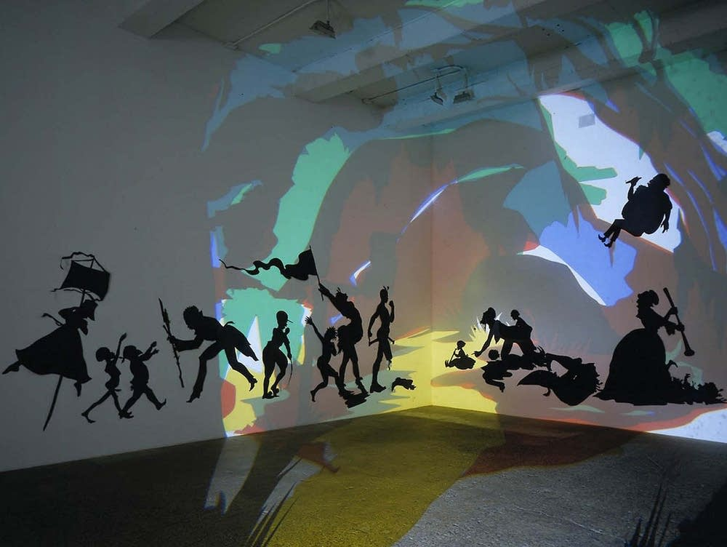

D)

C))

B)

A)

<https://smarthistory.org/kara-walker-darkytown-rebellion/>

4)How does Walker translate 5) List (3) Historical Facts about Silhouette: 6) List the mediums that

History and or the past to a visual form? A) compose the installation.

B)

C)

7) What was Walker’s inspiration for the work? 8) How is the work constructed 9) How does Walker draw a connection

on the museum walls? between

historical & contemporary issues?