Christian Art 1- Late Antiquity & Byzantine Art

<https://www.youtube.com/watch?v=Z63viMkyaf4>

1) Why is the 3rd century a “grim” or difficult time for the Roman Empire?

2) The 3rd century soldier emperors reinforced worship of-

because

3) Why did the Christian annoy or trouble the Romans?

4) *Chi-Ro* is the ___________________________________________

5) Draw the *Chi –Ro*:

6) What was Constantine’s vision?

7) How did this vision change history?

8) Who issued the Edit of Milan? What is it?

9) Early Christian art comes from ~

10) Define:

Lunettes-

Polygonal Frame-

Loculi –

11) Why was the Christian church secretive and embattled?

12) The Catacomb of Priscilla is made from- and dated-

13) The architectural features of these catacombs are –

14) The Catacomb of Priscilla is similar to art in Pompeii because-

15) What does the Orant fresco depict?

16) What is a pendentive?

17) What Christian symbols are in the pendative of the Orant Fresco?

18) In the Good Shepard fresco, what are the images of the (4) lunettes?

19) The Basilica of Ulpia at the Trajan Forum is a –

20) Why did Christians adopt the Basilican plan for their churches?

21) Santa Sabina is a ________________________that is made from ________________________

Dated at __________________________________________.

22) Spolia is –

23) 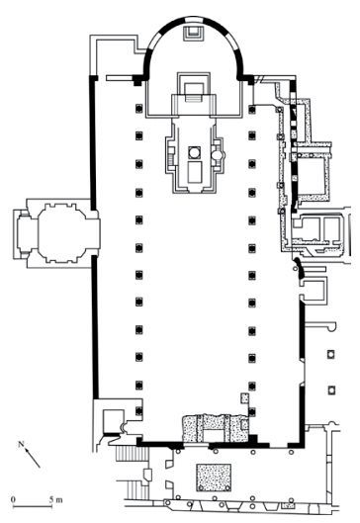

Identify A, B, C

23) Why did the art of the catacombs focus on resurrection not crucifixion?

24) Churches used art to_______________________________________, this was especially important in the Middle Ages because_____________________________________________________________.

25) Who is Constantine?

26) What did Constantine do in 330?

27) Why?

28) Who declared Christianity the legal religion of the empire?

29) Why is Ravenna Italy important?

30) Justinian was-

31) What two churches did he commission?

32) What are the changes in the portrayals of Christ?

Christian Art 2 Byzantine Art view to 4:24

1) An illuminated manuscript is-

2) Vienna Genesis has _________________________which causes the work to-

3) A continuous narrative is-

4) The classical characteristics of the Vienna Genesis are-

5) Describe the depiction of the human form in the Byzantine mosaic-

6) The classical elements in *Rebecca Coming to the Well* are-

And what are the Byzantine characteristics-

7) The Vienna Genesis is the oldest-

8)and sows the transition-