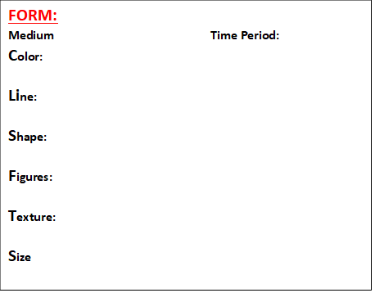

**FUNCTION**

**ART THEME:**

**ICONIC BECAUSE-**

**INFLUENCED –**

**BASED ON-**

**CONTENT:**

**Painting Depicts-**

**Celebrates-**

**Venus’ eyes or gaze-**

**Contrast of-**

**Chiaroscuro is evident-**

**Linear Perspectives-**

**Glazing is-**

**The painting is glazed-**

**Culture-**

**Title-**

**Artist-**

**ID. (2) Anatomical Problems with the Composition-**

**CONTEXT**

**Painted for (Patron):**

**Titian is renown for his use of-**

**Which can be seen –**

**Its hung in the Museum of-**

**Called a “Venus” because-**

**Sensuality is achieved by-**

**Painting creates the tradition of-**

**Canvas divided-**

**Which creates the effect-**