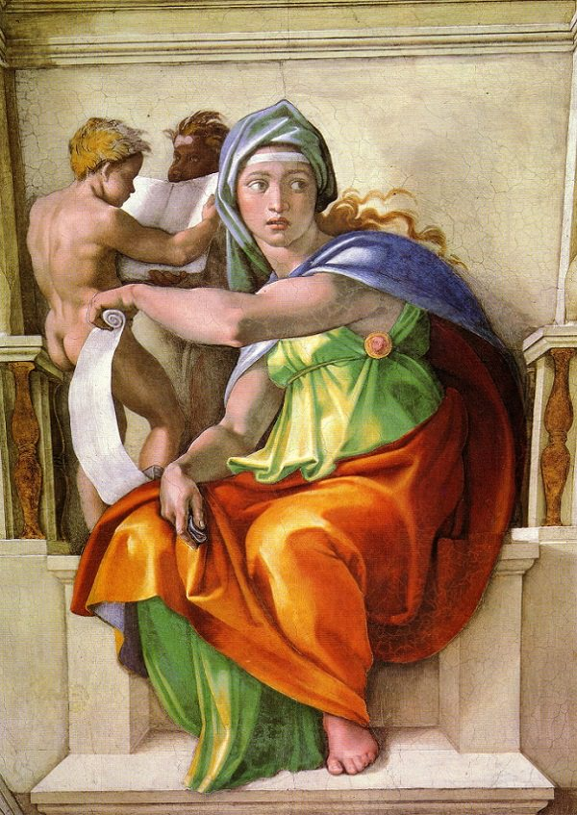

**The Delphic Sibyl by Michelangelo**

In the rows of figures which Michelangelo painted along the arched portion of the ceiling of the Sistine Chapel, the prophets are associated with sibyls. Hence, in the plan of decoration, there comes first the figure of a man, and then the figure of a woman. Now, as the Bible contains no allusion to sibyls, it may seem strange that they should have a place in a series of Bible illustrations, and especially that they should appear side by side with the prophets. To explain this, we must learn something about the sibyls.

They were women of ancient times supposed to have supernatural gifts of foretelling the future. They devoted themselves to solitude and meditation, and sometimes lived apart in caves or grottoes. Sometimes they were connected with temples, and delivered what were supposed to be the messages of the gods to the worshippers. These messages were called oracles, and were greatly revered by the people who consulted the gods.

Some of the sibyls' words of wisdom were committed to writing and passed down to following generations. Though they lived in heathen countries, the tradition ran that they prophesied the advent of Christ. There is a passage in one of Virgil's eclogues (the fourth) upon which the supposition is based. Early in the Christian era, when men were spreading the new faith, they made much of these sibylline prophecies to add weight to their teachings.

In former times, fact and fable were very often confused, and people did not take pains to distinguish the legends of the sibyls from the history of the prophets. When the Latin hymn "Dies Irae" was written, the sibyl was mentioned, with the prophet, as predicting the final destruction of the world. Many painters and sculptors gave the two equal honor in the same way. In the prevailing opinion, the sibyls shared with the prophets an inspired foreknowledge of the Christian faith.

The nine main panels of Michelangelo's ceiling decoration show how man was created, and how he was tempted and fell into sin. To carry on still further the story of the human race, the painter shows the succession of men and women, prophets and sibyls, who, one after another, predicted the redemption of the world in Christ. On the side walls, below these figures, the story is carried to completion in a series of pictures illustrating the life of Christ. The last named frescoes were painted by various artists some years before Michelangelo's work on the ceiling