**Create a Silhouette of Your Profile**

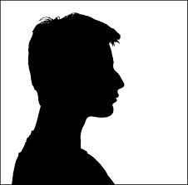

**STEPS:**

1. Take a side profile photo against a blank space like a solid color wall

Profile shot needs to be from the shoulders up

1. Reduce or increase size on your computer to desired size.

Trace the image onto white copy paper

1. Place White paper with tracing on top of Dark/Black paper & cut out shape
2. Mount onto White cardstock/paper for framing with double stick tape or glue onto page
3. At the bottom-Write= Name

APAH #Period

**Tips:**

*For longer hair, photographing buns or ponytails make creating a silhouette simple & beautiful.

*Curly hair can be difficult to photograph & cut. If you have trouble, find a silhouette that works & trace that hair, placing it on your stencil to cut on your black cardstock.