Name Date Period

Raphael’s School of Athens

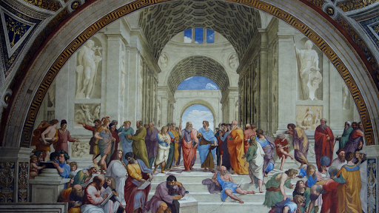

I**) Art Analysis**

1) Identify Figures: 2) Circle & Identify (4) Greco Roman Architectural Features

(Use Khan Academy)

<https://www.khanacademy.org/humanities/ap-art-history/early-europe-and-colonial-americas/renaissance-art-europe-ap/a/raphael-school-of-athens>

A)

B)

C)

D)

**II) Art Research**

View the Video Lecture Below & Answer the Questions

<https://www.youtube.com/watch?v=PyhVZ89GdGw>

1) It was painted between _____________ & depicts______________________________.

2) It copies the ___________________________of the Roman period.

3) The figures do not _______________________but______________________________.

4) Which figure & his students personify learning?

How?

5) The________________ lines draw the eye to__________________________________

Who are engaged in the central disagreement in western thought –

6) This ____________was painted in a ______________________by the commission/patronage of_________

7) Stanza dela Signatura means _______________________and is the Pope’s _________________________

8) This work was one of _______________________painted in the room, each wall representing-

9) The painting is placed in the environment of_______________________________________________,

10) The message of the room is____________________________________________________________.

11) The architectural structure

A) Reveals Culture-

B) Imitates-

C) Honors the Pope-

12) The background showcase this architectural works-

Go to =<https://www.artble.com/artists/raphael/paintings/school_of_athens>

1)The painting represents this type of community:

2) Raphael creates a -

3) It is painted on a vision of a -

4) At the center is-

5) Plato gestures _______________________to

6) Aristotle points _______________________ showcasing the world of-

7) These two philosophers are surrounded by-

8) Raphael’s intent/goal for the work was to-

9) The painting has a theme of-

10) The room the painting is in was used-

11) Raphael build interior perspective by-

A)

B)

C)

12) The light in the painting comes from-

13) The Renaissance audience reacted –

In comparison to the Sistine Chapel which reception was-

14) In his lifetime, Raphael was considered-