**Romanesque vs. Gothic Architecture Analysis Poster**

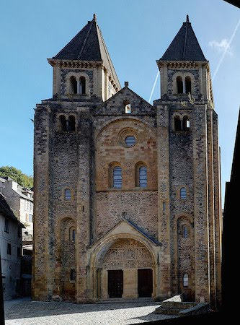 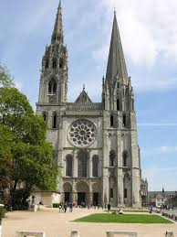

**Church of Sainte-Foy  Chartres Cathedral**

**Construct a Poster that has the following features-**

**1)An image of the TYMPANUM(s) of both buildings with an explanation of the narratives illustrated within the TYPANIUMS**

**2) (2) Similarities and (32 Differences of the TYMPANIUM**

**With explanatory images**

**3) (5) Labeled EXTERNAL ARCHITECTURAL ELEMENTS of each Church’s façade**

**4) The Location & Function of each church**

**5) An image and explanations of the RELIC of each Church**

**6) Historical CONTEXT of each Church**

**(Patron, Back Story, Unusual Facts, Present Day Usage)**

**7) Why each church defines its ARCHITECTURAL PERIOD?**

**Church of St. Foy = (4) Romanesque Characteristics**

**Chartres Cathedral= (4) Gothic Characteristics**

**Include (1) Images of Each**

**8) (2) Differences of the Two ARCHITECTURAL STYLES**

**With (2) Explanatory Images**