Name Date Period

ROME: THE ORGANIZER

**Page 16**

I) College Notes (Summarize the First Sentence of the Paragraph & Bullet the Supporting Details)

II)

Philosophy:

Art Forms:

Most Famous Building:

Role Model:

Major Contributions:

III)

Difference between a Greek & Roman Temple

Identify the Attribution of the Building Below:

Identify A, B, C, D & E

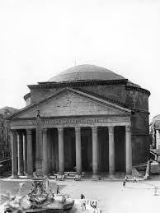

B.

C.

D.

E.

E

A

**Page 17**

**Concrete allowed for-**

**Basilica-**

**Barrel Vault-**

**Groin Vault-**

**Notes on *Roman Architecture*:**

**Notes on *Roman Sculpture*:**

**Page 18**

**Notes on *The Colosseum*:**

**Page 18**

**Notes on *Pompeii: A City Turned to Carbon*:**