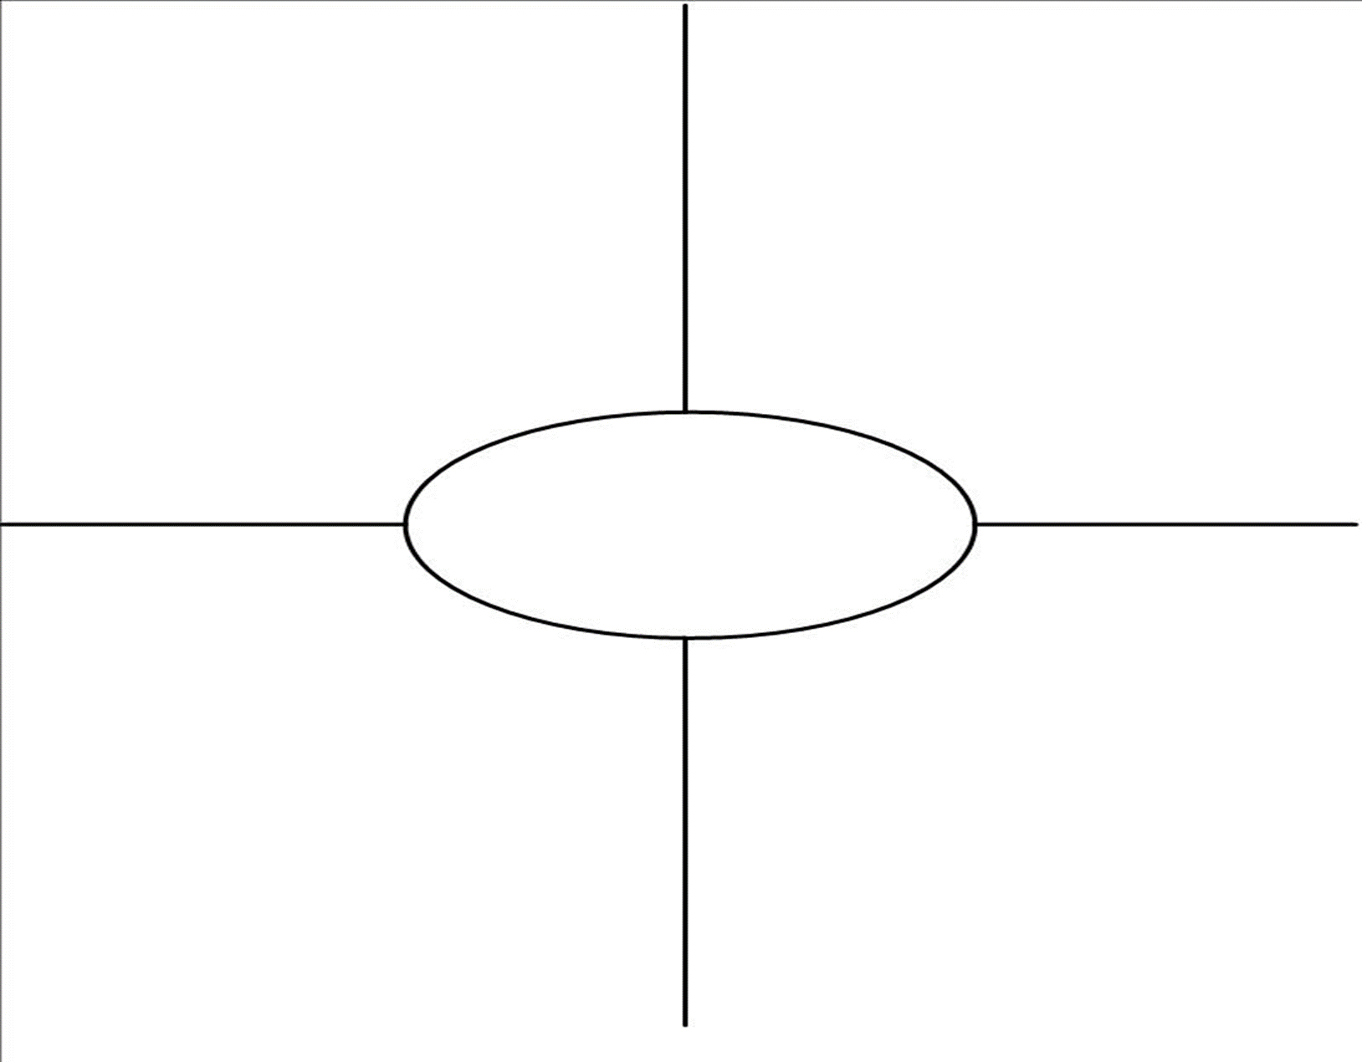

**CONTEXT:**

Line-

Shapes-

Texture-

MATERIALS/MEDIUM-

**CONTENT:**

Historical Narrative:

Figures:

Art Technique:

How the Sculpture Communicates a Cultural Meaning?

Patron:

Audience Reaction:

Impressionist Features:

Change from Tradition:

Function:

Artist Intent/Goal:

Art Themes

**The Burghers of Calais, Auguste Rodin**