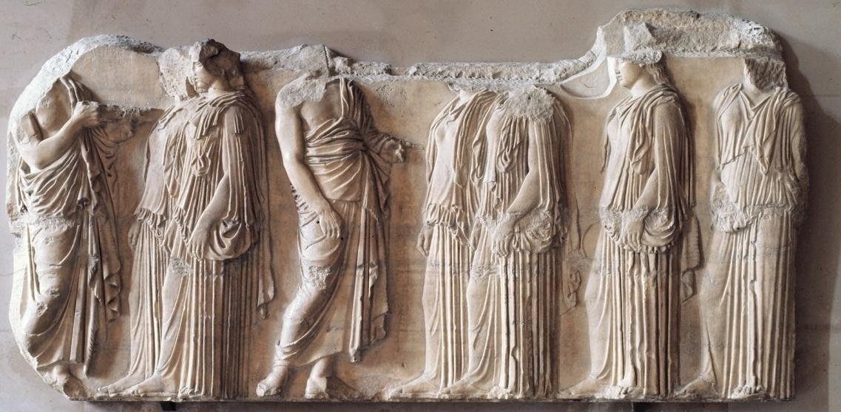

**8. CROSS CULTURAL COMPARISON WITH OTHER WORK IN THE 250:**

**Title:**

**Explanation of Similarity:**

**7. INNOVATION/ CHANGE(S) *from the Established Norm* :**

**6. CONTEXT:**

**Audience:**

**Patron:**

**History:**

**Cultural Intent:**

**1. IDENTIFICATION:** (Artist, title, date, size, country of origin, period/style)

**2. FORM:**

**C=**

**L=**

**A=**

**S=**

**S=**

**3. MATERIALS AND TECHNIQUE:** (art making processes)

**Material=**

**Art Technique=**

**Location in the *Parthenon*=**

**4. CONTENT:**

**Narrative:**

**Figures & Objects in the Work:**

**Location in the *Parthenon*:**

**5. FUNCTION:**

**ART THEMES:**