Neo-Classical – Post Impressionism
Study Guide
Know the Title, Artist, Art Movement & Narrative/Context of the Following Works
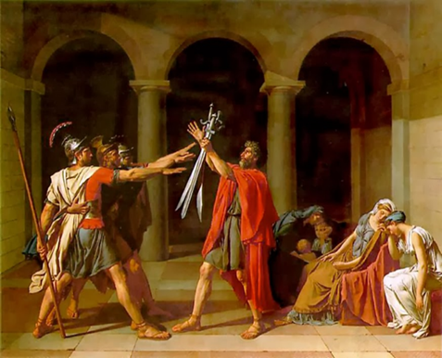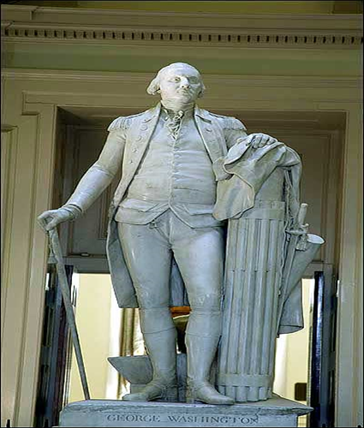

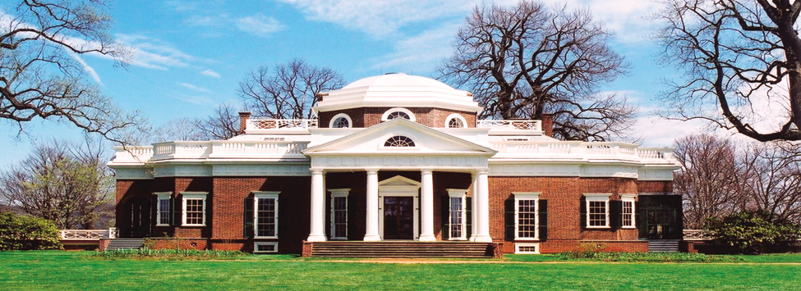
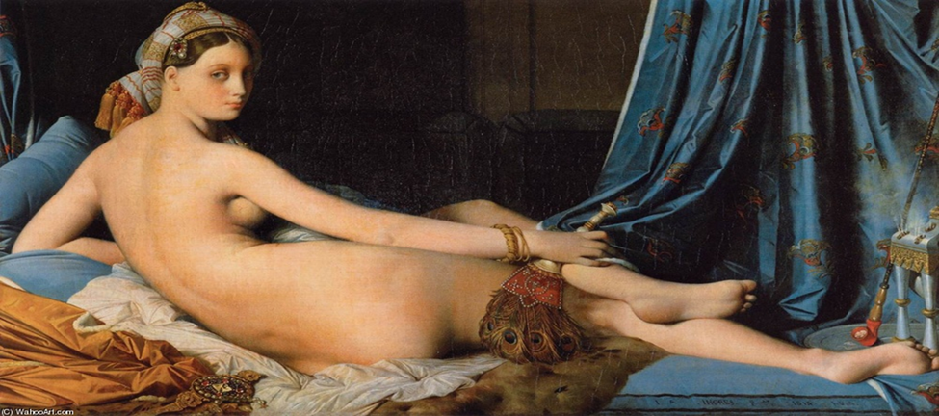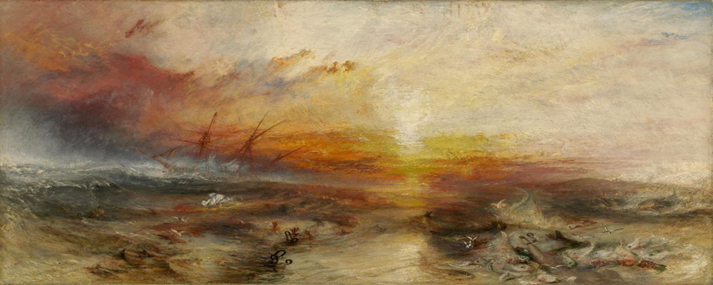
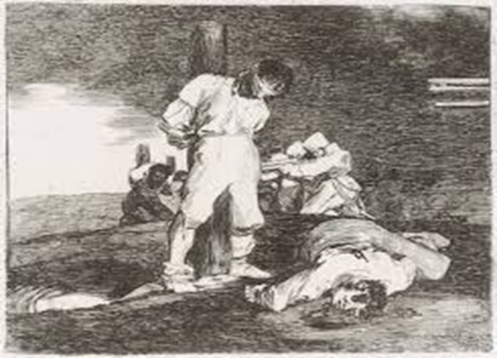
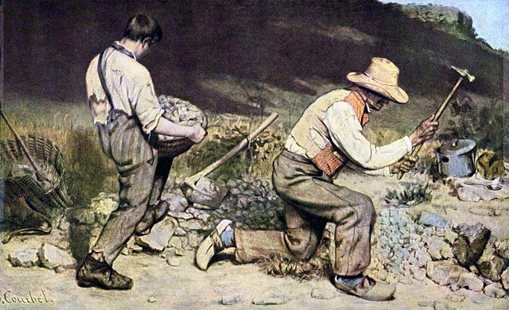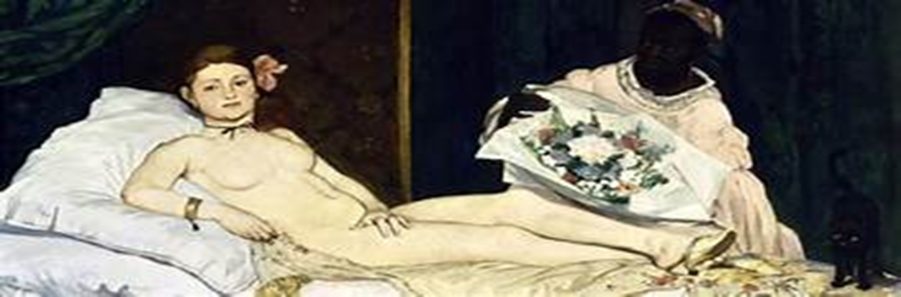
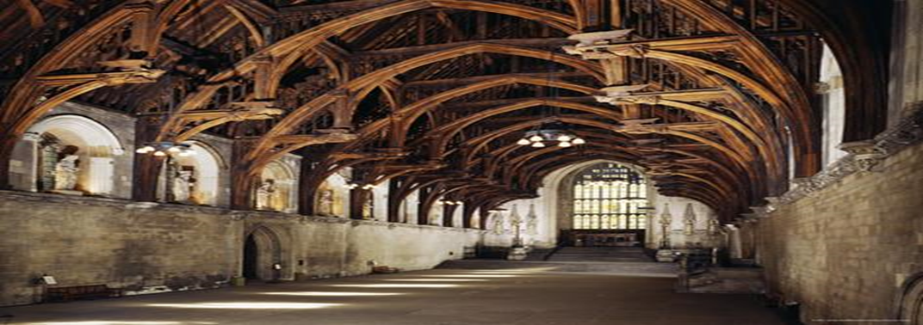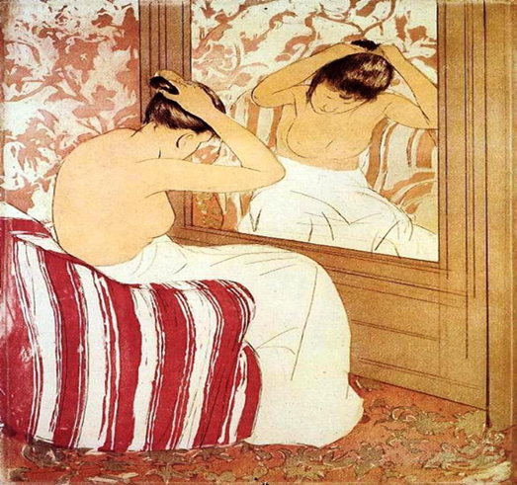
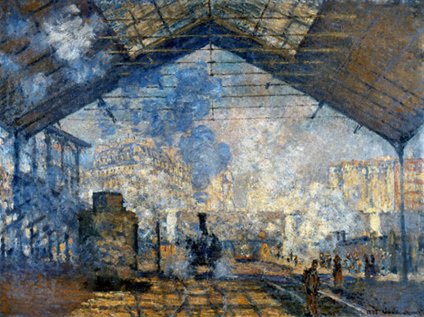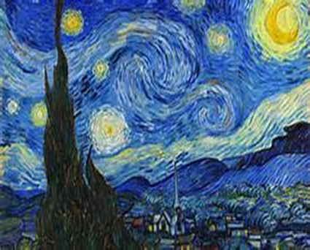
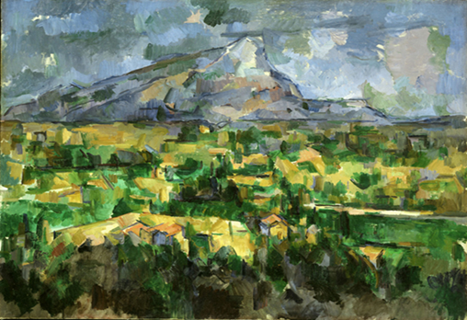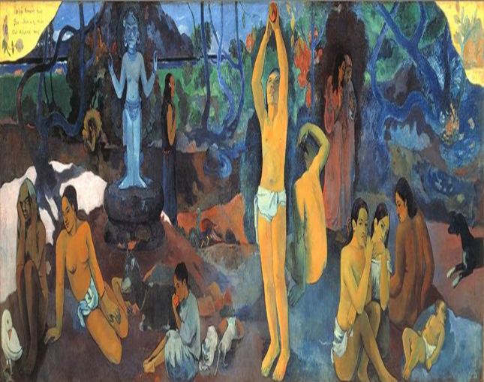

KNOW
1) Characteristics of Neo-Classical & Romantic Art
2) Why Realism was disliked by the Academy?
3)Define Japonisme & its Influence on Art
4) Know E.L.B.O.W
5)Neo- Gothic Characteristics
6) The Cultural & Allegorical meanings of
Cole’s The Oxbow & Velasco’s
The Valley of Mexico from Santa Isabel Mountain Range
7) Characteristics of Impressionism & Post Impressionism

