Japanese & Chinese Study Guide
Know Culture Specific Vocabulary:
Axis Mundi
Axial Plan
Bodhi
Mudra
Nirvana
Urna
Stupa
Dharma
Ushnisha
Bodhisattvas
Gopura
Ashlar Masonry
Vishnu
Pagoda
Handscroll
Daoism
Confucianism
Colophon
Porcelain
Coiling
Meridian
Diabatsu
Ukiyo-e
Yamoto-e
Rinpa
Shamanistic
Samurai
Joint Block Technique
Wabi-Sabi
Dissident
Moat
Zen

Art Images & Concepts
1) Angkor Wat
Know the Title, Function, Location & Religion these Images

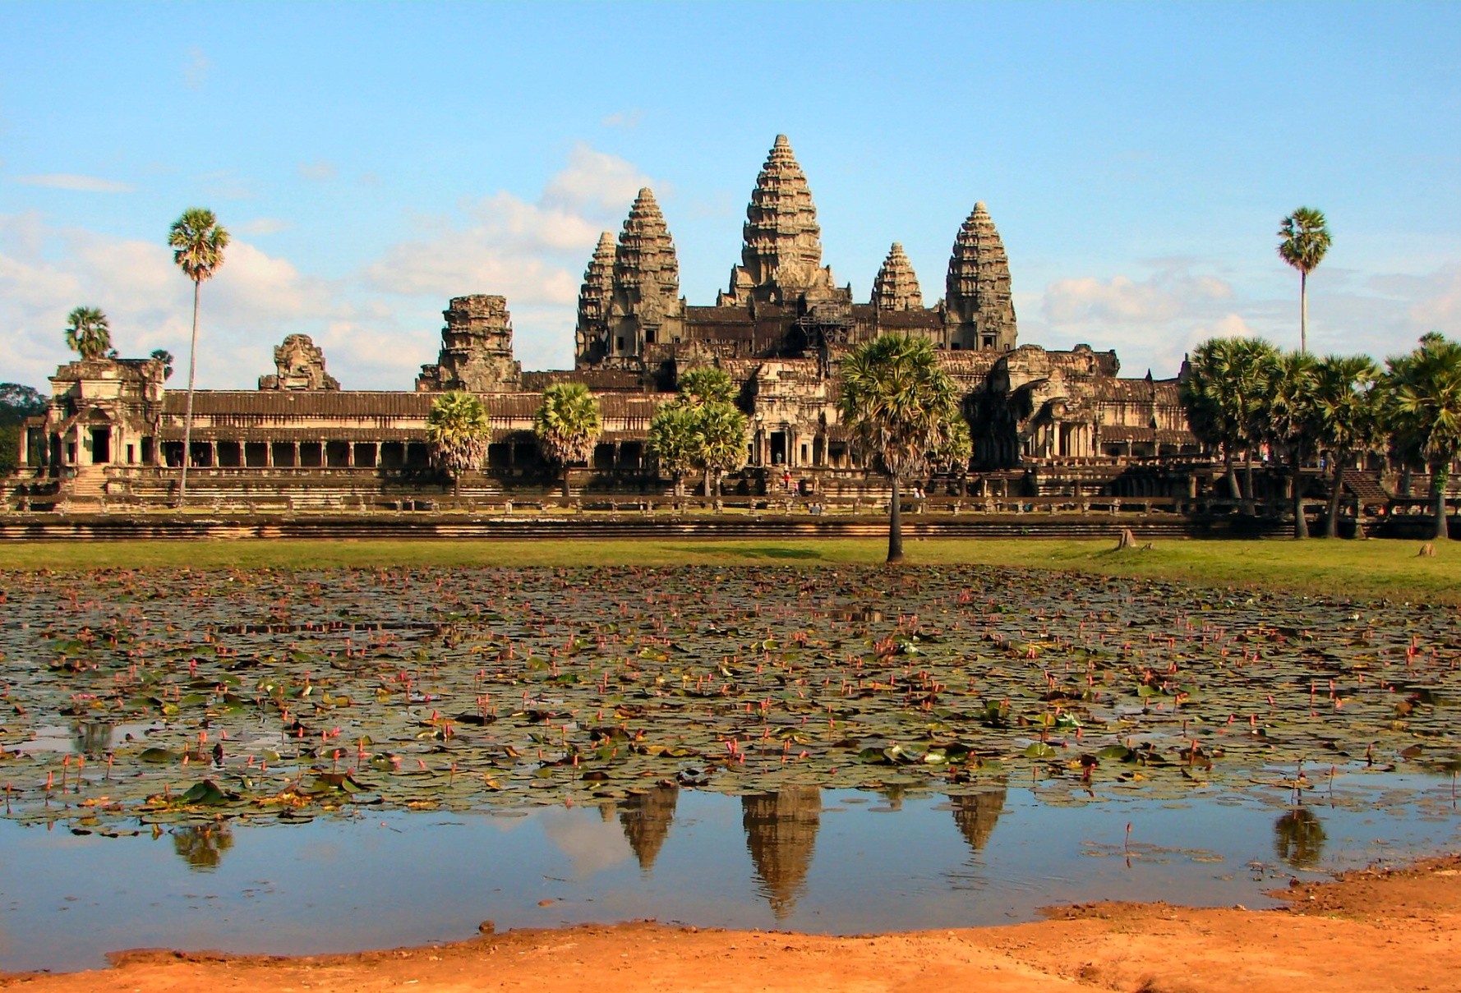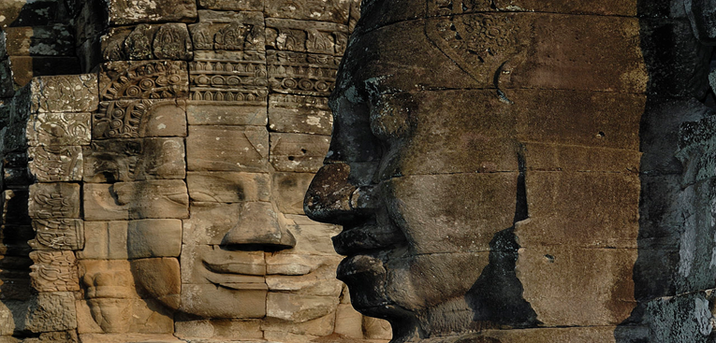

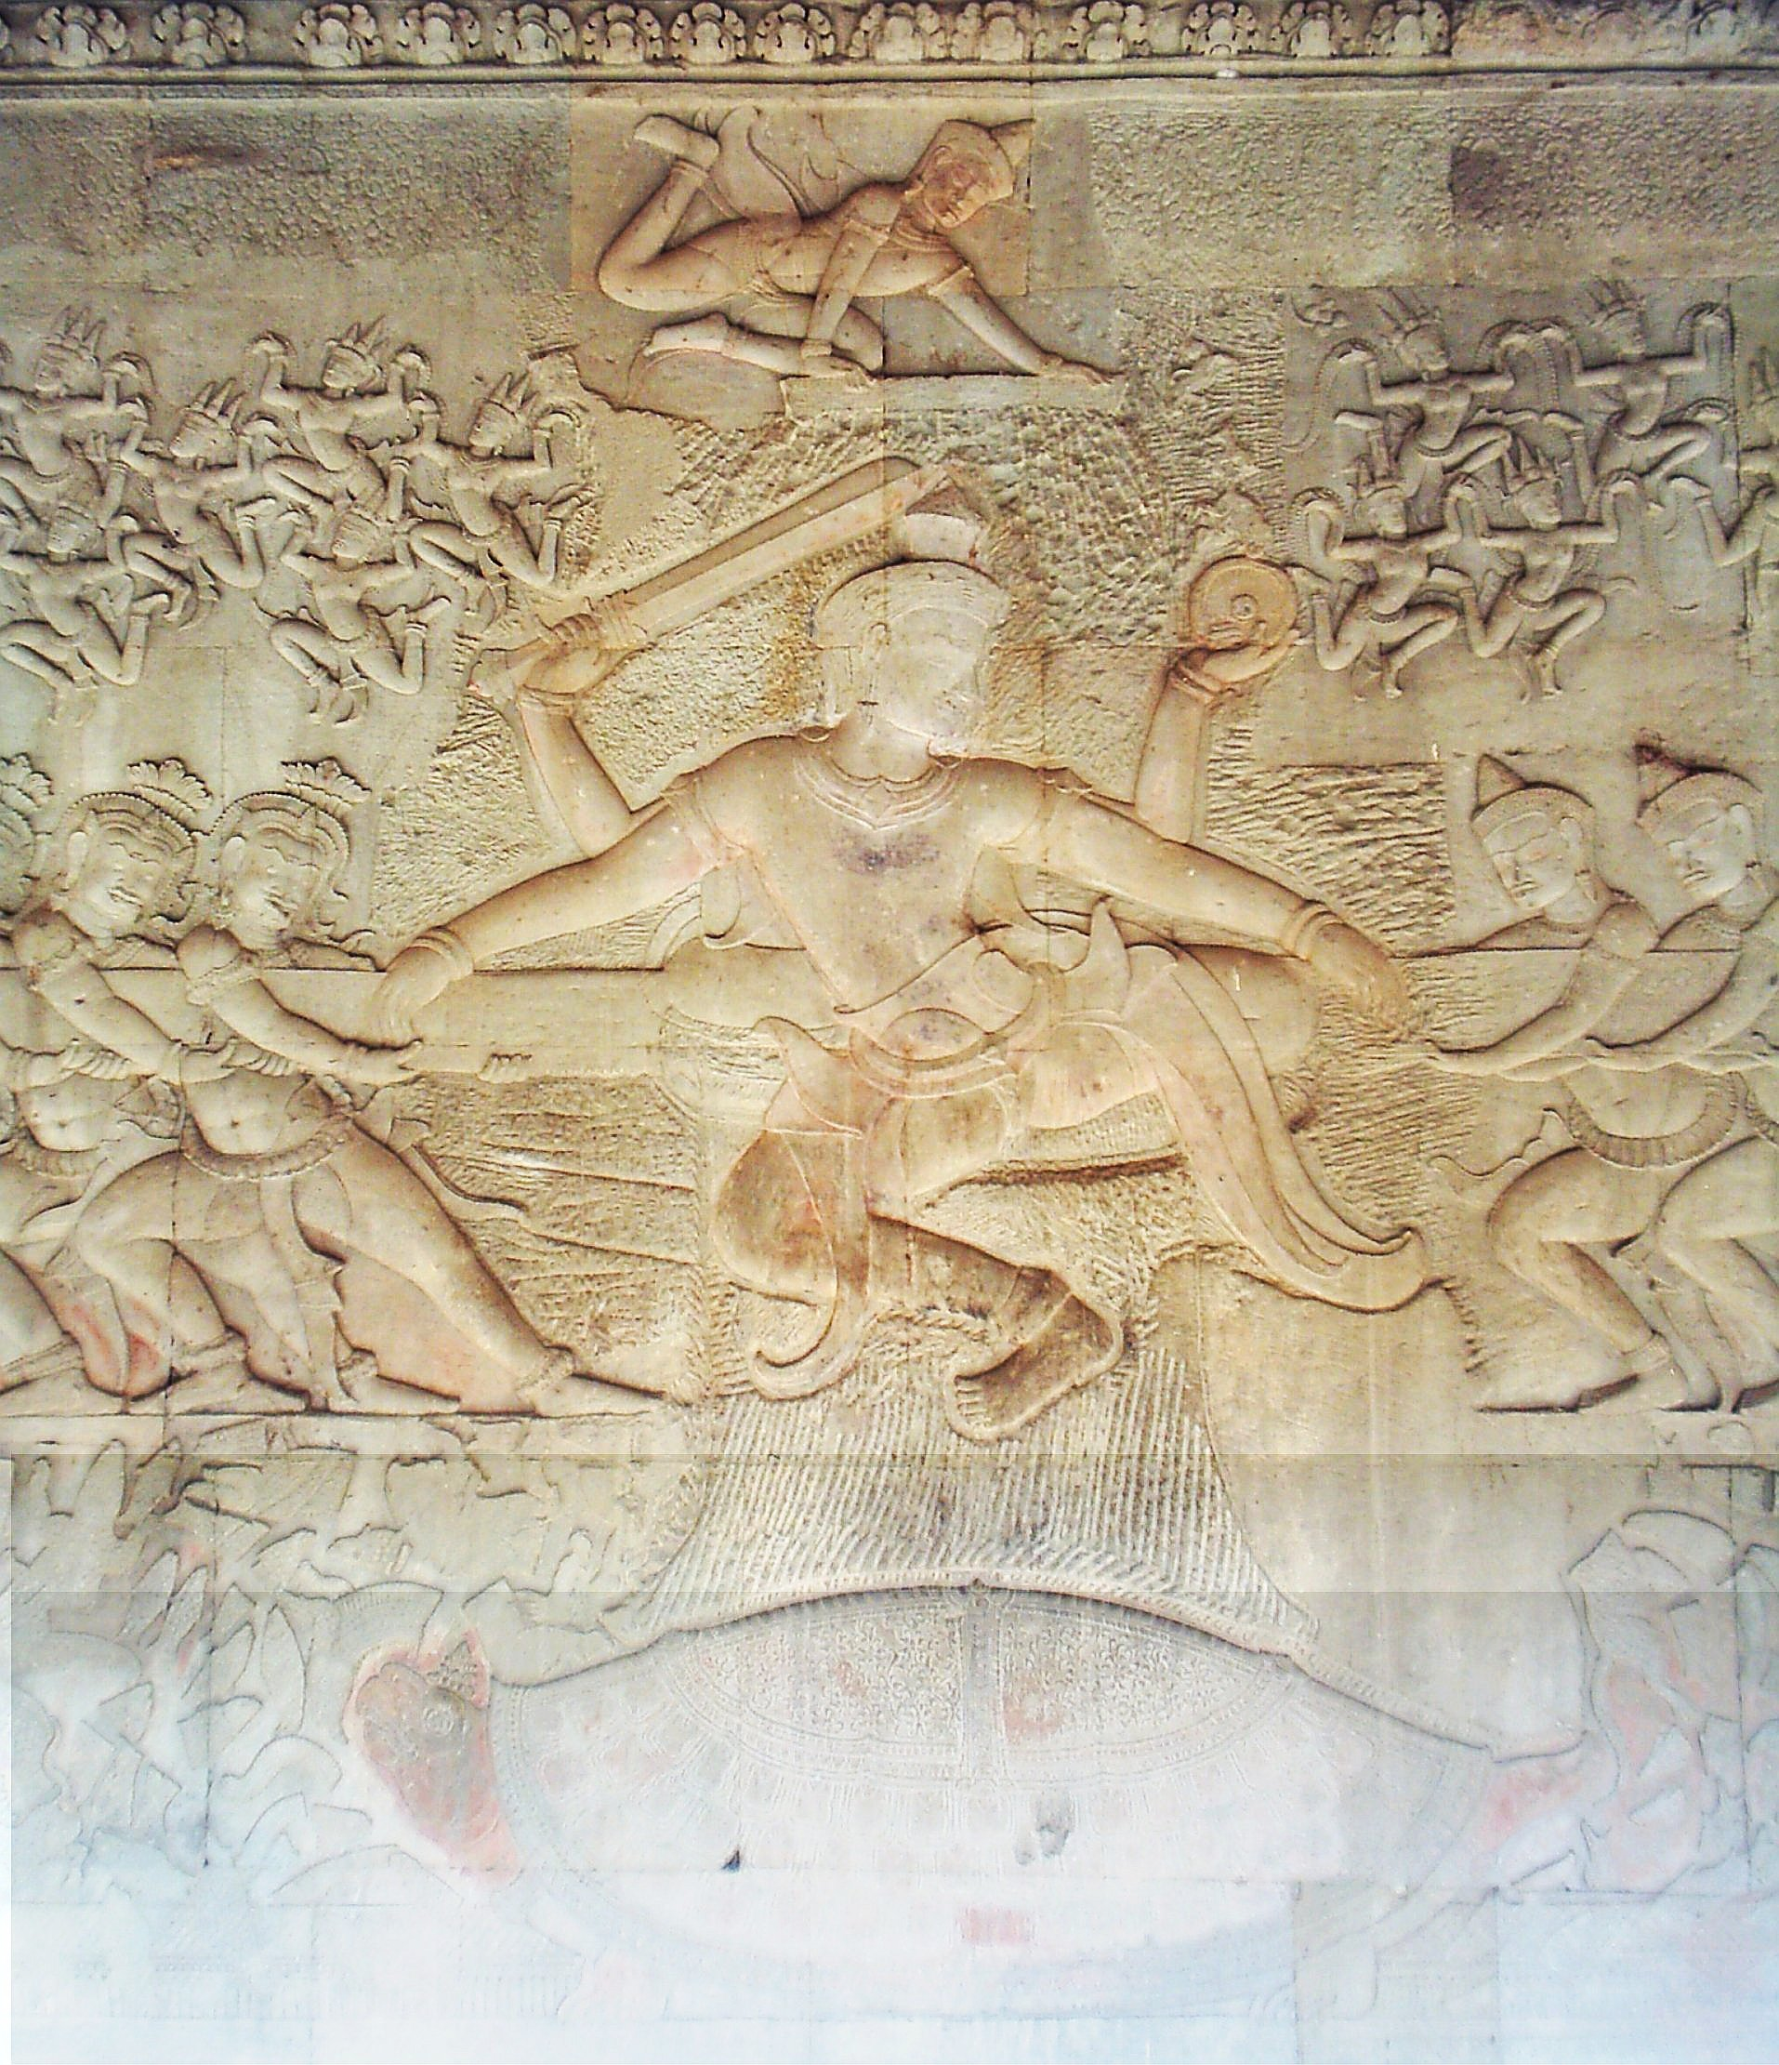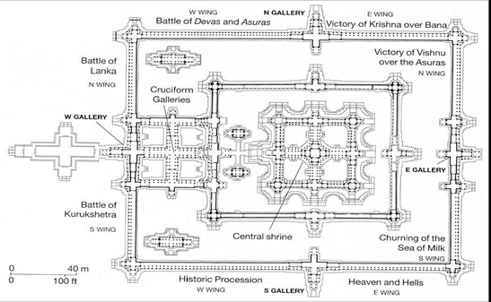

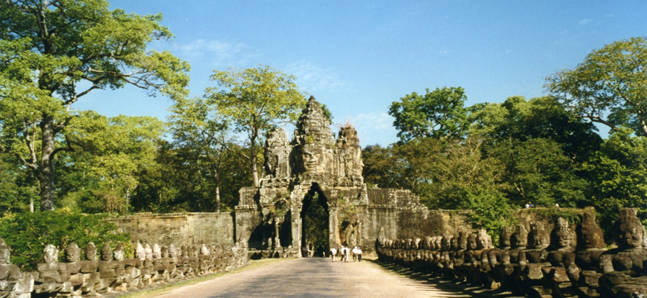
Know the Narrative for this Image
2) Know the Parts of a Buddha Sculpture
3) Todai-Ji
Know the Title, Function, Japanese Culture (Samurai or Imperial Court) & Religion these Images
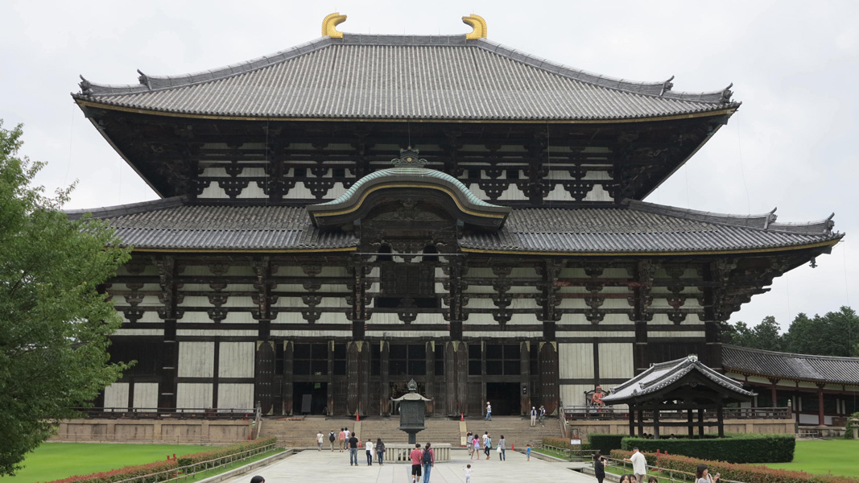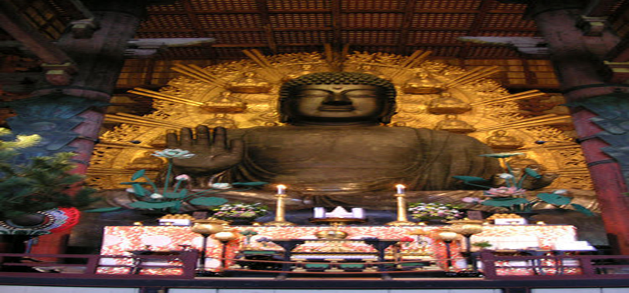

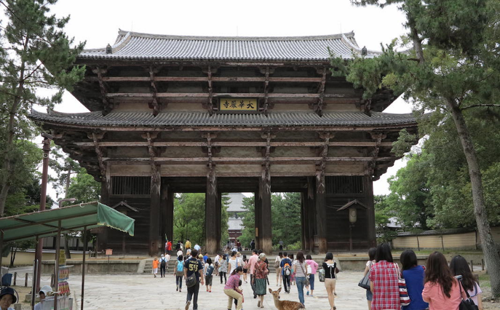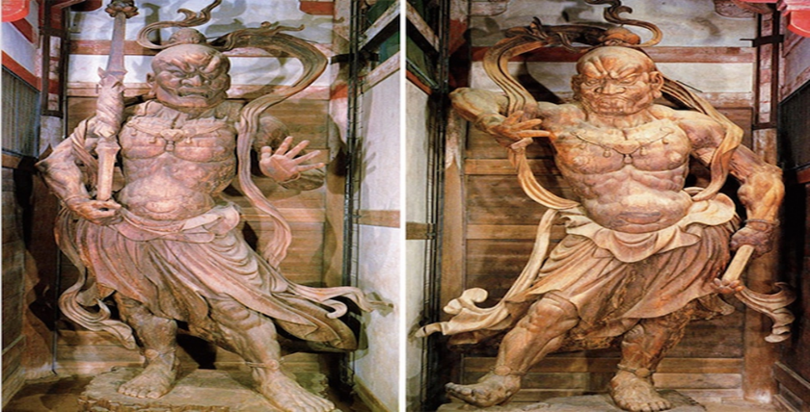

4) Ryoanji- Peaceful Dragon Temple
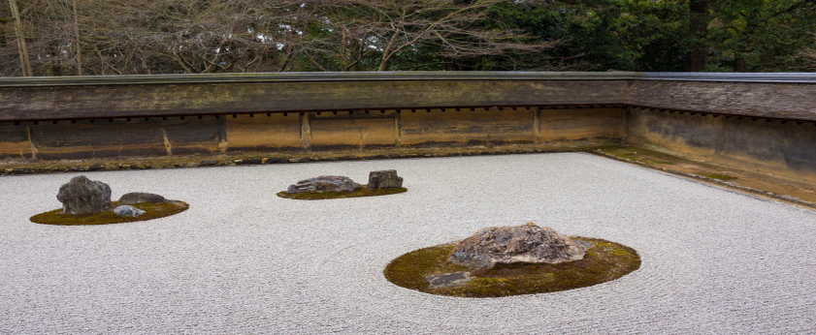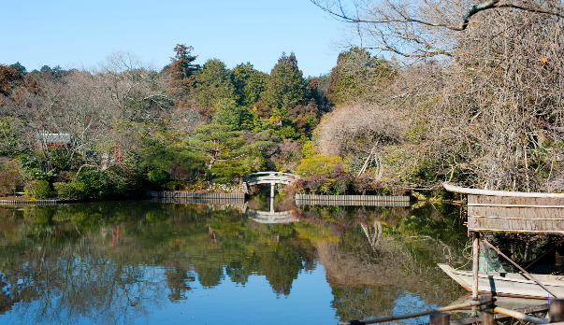
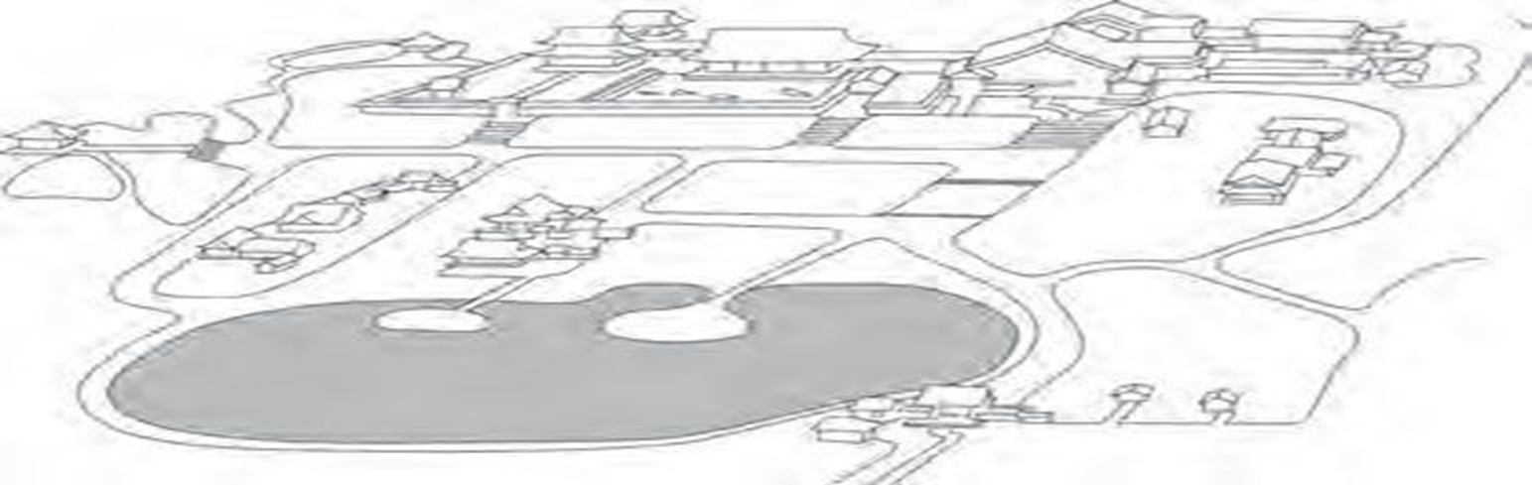
Be Able to Identify the Temple, Zen Garden & Wet Garden
5)Japanese Painting
ID- Title, Artist Function, Painting Style
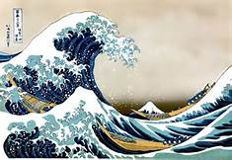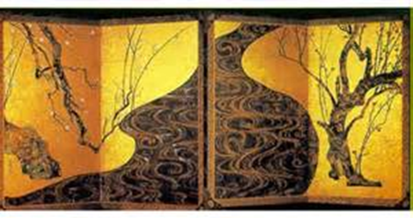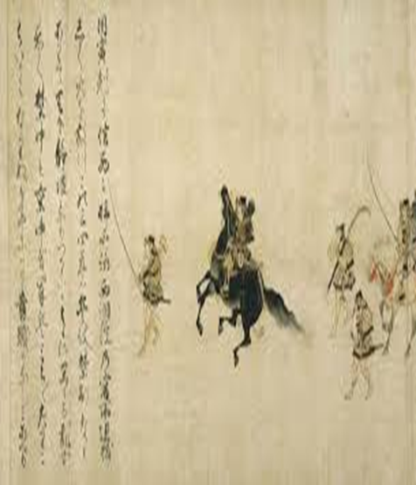
6) Chinese Art-Identify Title, Function & Histoirical Significance
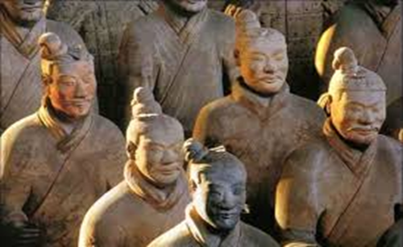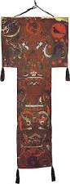
Know the Subject of the Four Registers

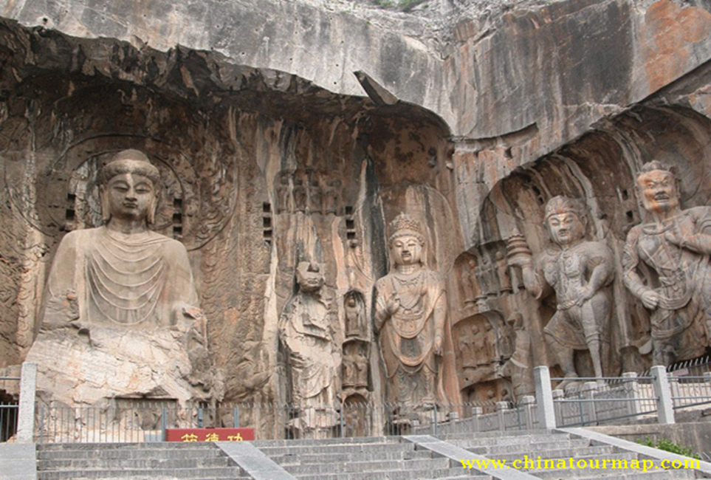
Be Able to Discuss the Buddha & Demi -God
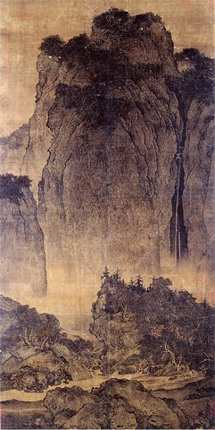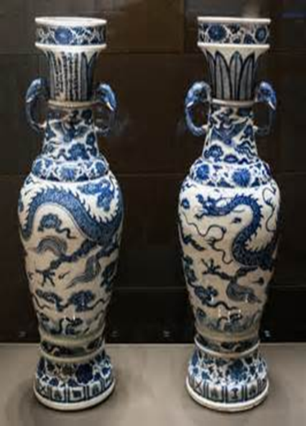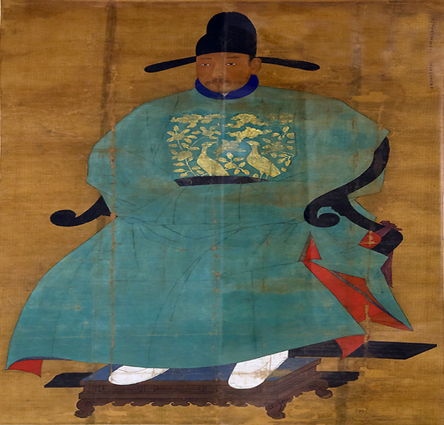
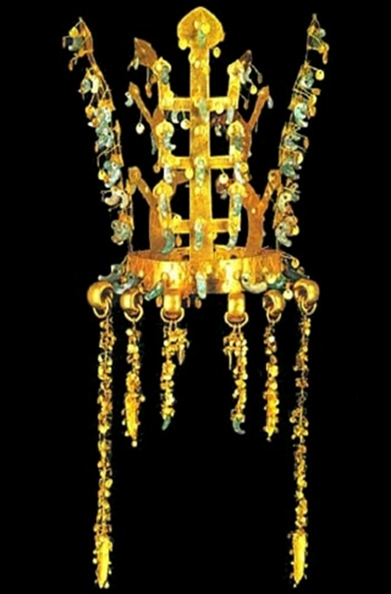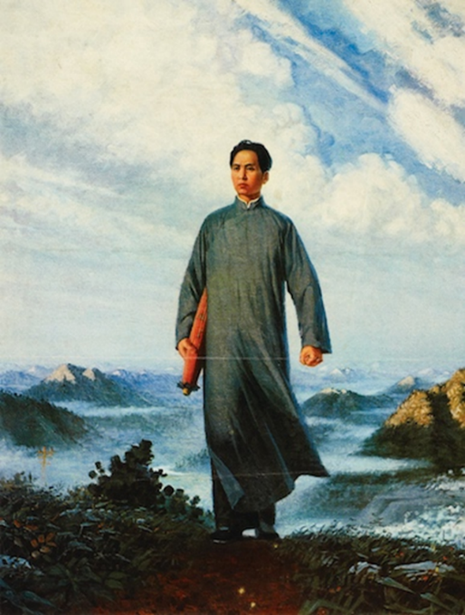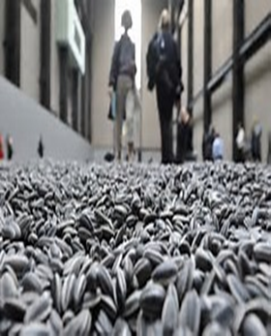
Be Able to Id the Key Features of Each of the Above Works

7) Imperial Forbidden City- Identify Title, Function & Histoirical Significance
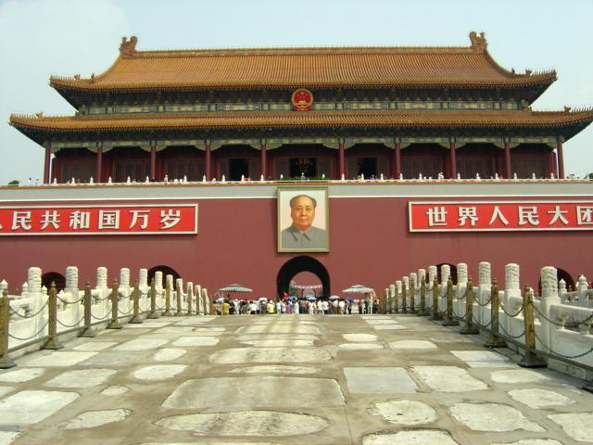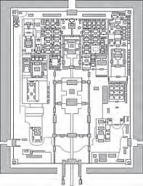
Id.
*Meridian Gate
*Division of Inner &
Outer Court
*Guard Tower
*Moat

& Outer Court
Moat
