**Islamic & Japanese Art Study Guide**

***Know the following Vocabulary:***

**Islamic Japanese**

*Kufic *Shinto

*Aniconic *Urna

*Mihrab *Shamanism

*Minaret *Diabutsu

*Qibla wall * Zen

*Minbar * Shogun

*Umma *Samurai

*Quran

* Iwan

*Imam

*Kiswa

*Tessellation

*Arabesque

*Ablution Fountain

*Circumambulate

*Ambulatory

***Know the 5 Pillars & How they Manifest in Art & Architecture***

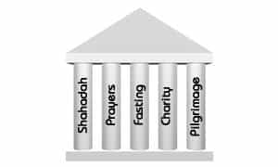

***Know the Title & Function of Islamic Art***

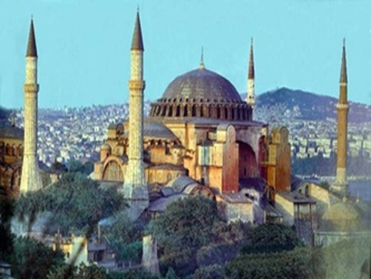 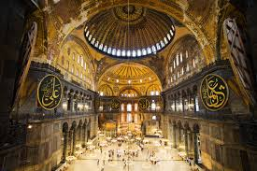

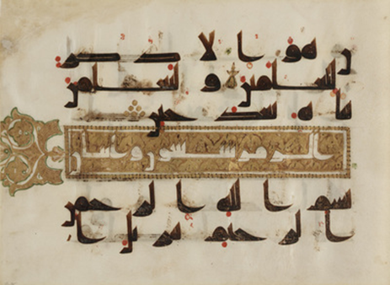 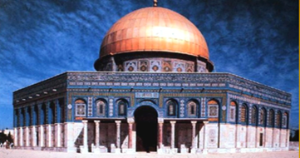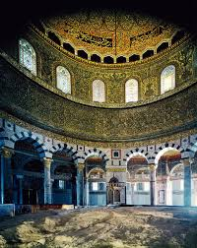

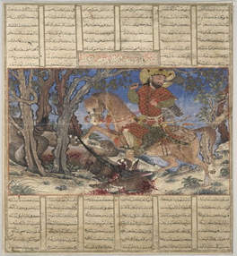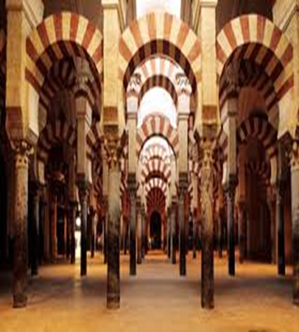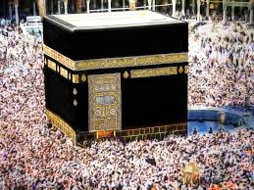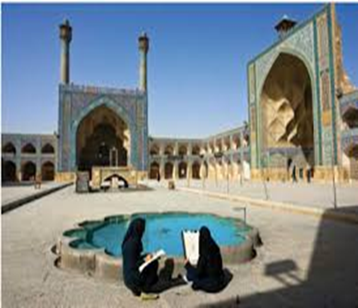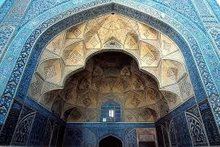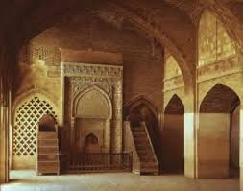

Know Innovation

Interior of the

Hagia Sophia

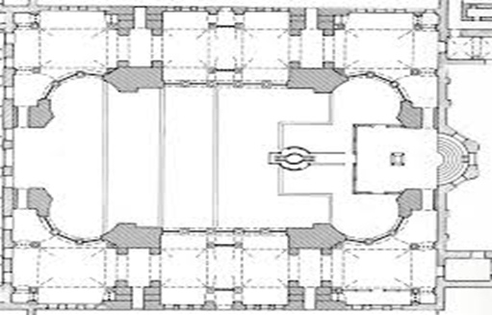 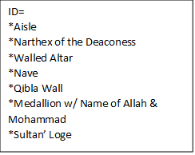

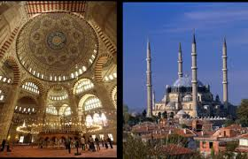

Know the Innovation

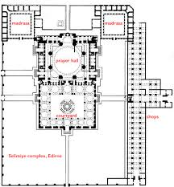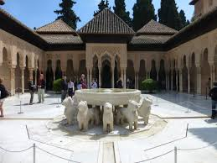

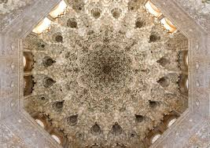 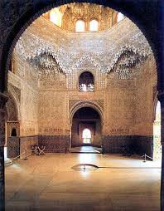

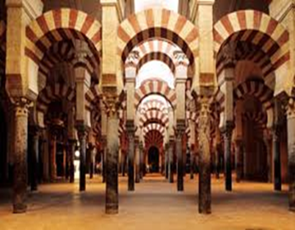 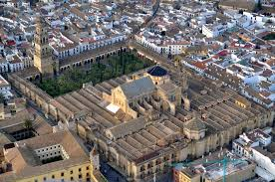

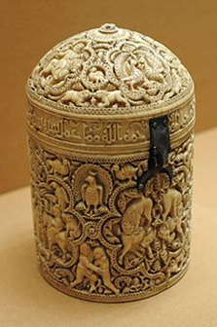

KNOW DETAILS OF THESE 3 LUXURY ITEMS

**Pyxis of Al- Mughira**

* Islamic Spain
* Air Freshener= Luxury Item
* Horror Vaculi
* 8 Medallions= validating and celebrating power
* Inscription on Rim=Owner’s Name= Shah’s Son,
* Ask for Blessing of Allah & tells Function
* Bas – Relief on Ivory

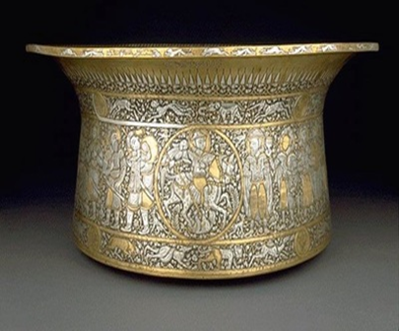

**Basin of Muhammad Ibn al- Zain or Baptistere of St Louis**

* Islamic
* Brass with inlaid gold & silver
* Transformation over time= Islamic Ritual Washing Before Prayer

TO

* Basin to Baptize Catholic French Royalty
* Four Horseman in Medallion= Power & Authority
* Hunting & Battle Scenes
* Bottom Row==Fish, Eels, Crabs & Crocodiles

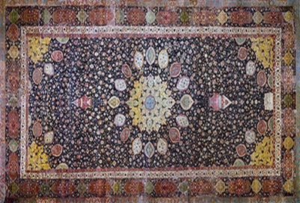

**The Ardabil Carpet**

* Funerary= Honors Dead
* Knotted Silk & Wool
* Prayer Rug
* Center looks like a Mosque= Dome & Lamps & Arabesque
* Border = Tessellations
* **Oldest Rug in the World**

***Know the Title and Function of these Japanese Art***

