Construct a

Tessellation or Arabesque

From One Buildings Below:

*The Dome of the Rock*

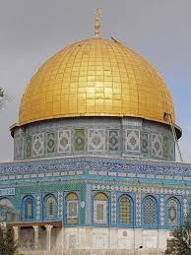

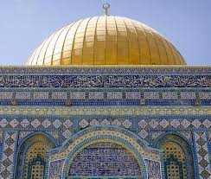

***Alhambra***

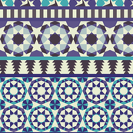 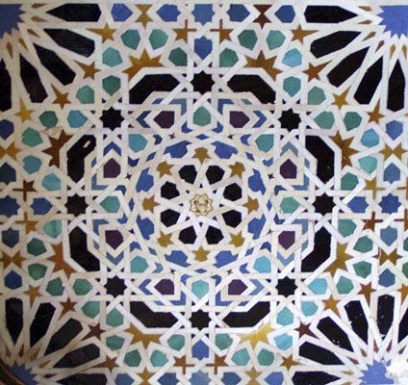

[*https://www.construction.com/CE/CE_images/2010/Jun_CeilingPlus_SS/slide.asp?slide=4*](https://www.construction.com/CE/CE_images/2010/Jun_CeilingPlus_SS/slide.asp?slide=4)

***Mosque of Selim II***

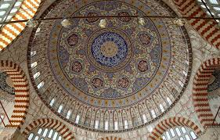

***Great Mosque (Masjid-e Jameh), Isfahan***

