***APAH-Islamic Flipbook***

***Create a Flipbook***

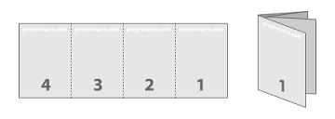

***Define the Vocabulary by (A) Definition and (B) Image/Picture***

***Define the Islamic Art by (A) Definition, (B) Three Characteristics & (C) Image/picture (D) Usage or Function***

*1. Minbar*

*3. Alhambra Palace-Granada Spain (Court of the Lions & Hall of the Sisters*

*4. Dome of the Rock-Temple Mount-Jerusalem*

*5. Great Mosque (Mezquita) - Cordoba Spain*

*6. Great Mosque- Masjid-E Jemeh-Iran*

*7. Iwan*

*8. Basin (Baptistere de St. Louis)*

*9. The Kaaba in Mecca*

*10. Koran/Qu ‘ran*

*11. Kufic*

*12. Mihrab*  
*13. Pyrix of al-Mughira*

*14. Mosque of Selim II- Turkey*  
*15. Qibla Wall*

*16. Bahram Gur Fights the Karg folio- from the great II-Khanid Shahnama*

*17. The Ardabil Carpet*