***APAH-Islamic Flipbook***

***( Worth Test Grade)***

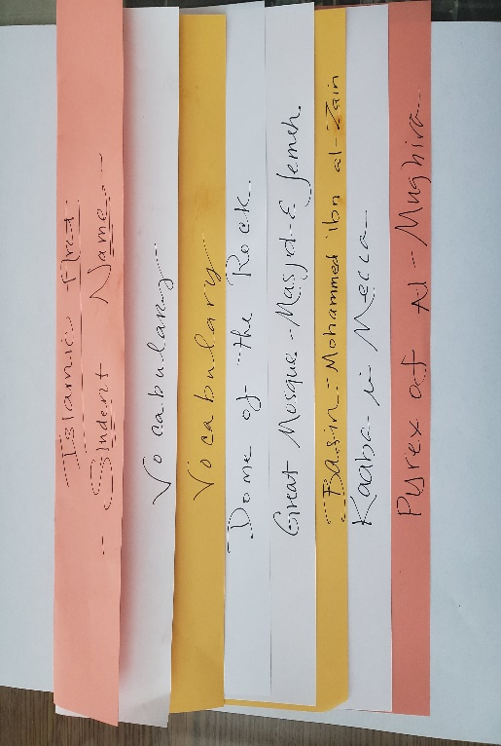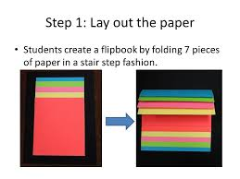

***Define the Vocabulary by (A) Definition and (B) Image/Picture***

***ANALYZE the Islamic Art by***

***(A)Title & Materials, (B) Three Visual Art Characteristics (C) Usage or Function (D) Image/Picture***

*1. Minbar & Qibla Wall*

*2. Iwan & Minarets & Mihrabs*

*3. Koran/Qu ‘ran & Kufic*

*4. Dome of the Rock-Temple Mount-Jerusalem*

*5. Great Mosque- Masjid-E Jemeh-Iran*

*6. Basin (Baptistere de St. Louis)*

*7. The Kaaba in Mecca*

*8. Pyrex of al-Mughira*

*9. The Ardabil Carpet ( placed on back)*