Name Date Period

**Greek Art Lecture: Greek Temples and the Acropolis**

1. List the4 components of a Sacred Space
2. Rituals in a Greek temple are performed_______________because the cella belongs exclusively-
3. The wealth of the temple was centered on –
4. Polis refers to –
5. What gives the Parthenon its illusion of flatness’/straightness?
6. The external colonnade is the –
7. What are Volutes?
8. How are Corinthian orders decorated?
9. What were the functional problems of the Temple of Hera?(These will be later fixed at the Parthenon)
10. Entasis means- and used to –
11. List 3 adjectives that describe Doric Temples.
12. The Erechtheion is the - which has- and is of this order-
13. Which culture utilizes the Corinthian order?
14. The Temple of Athena Nike uses the __________________________order and has friezes that illustrate__________________________________&__________________________________.
15. The Temple of Athena Nike is located at - at a historic location that was once used-

& is geographically advantages because-

1. What is Athena Nike holding in her hands?

What do they represent?

How does this connect with the Athenian character?

1. What two orders are present in the Parthenon?
2. Describe the Entablature:
3. Id these architectural elements:

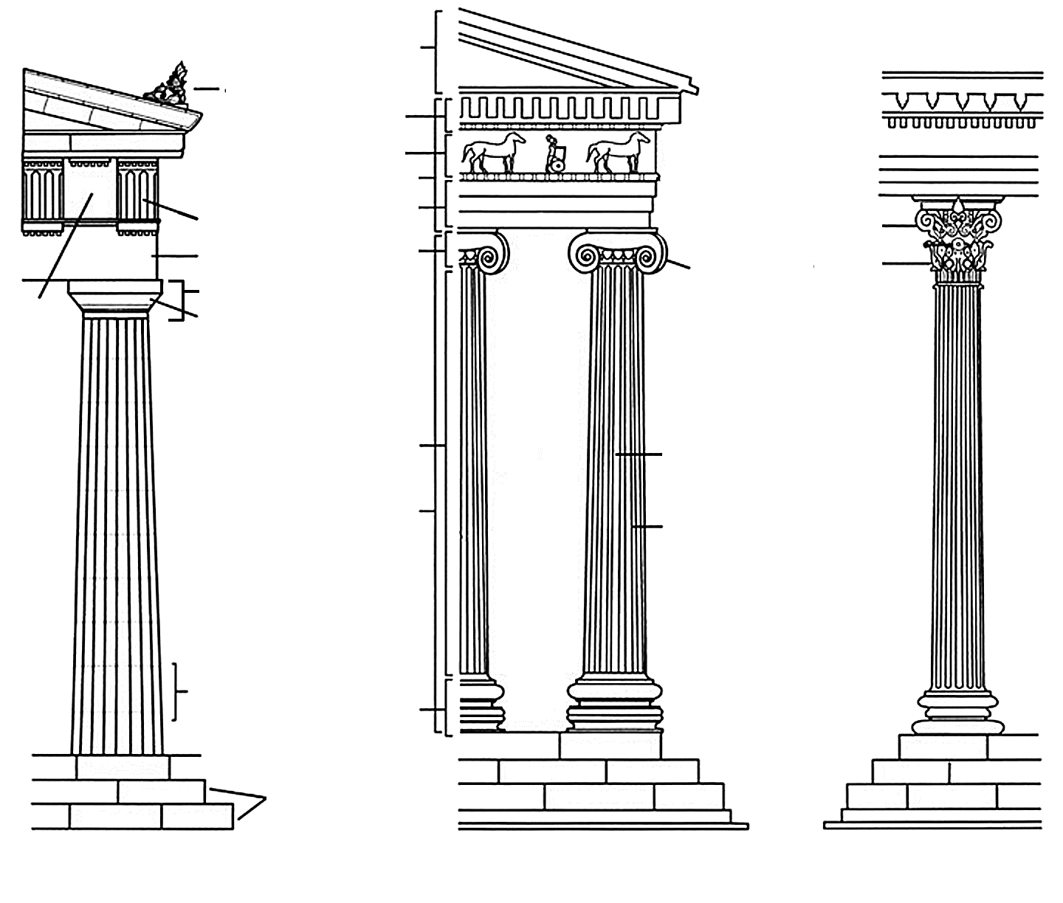

1. Why are optical illusions used in the construction of the Parthenon?
2. The inside frieze of the Parthenon showcases-

Because-

1. The outside frieze showcases-
2. The pediments showcase_______________________________&___________________________.
3. Why are the subjects reflective of Athenian character?