**Greek & Etruscan Art**

**Study Guide**

**Vocabulary**

Krater Entablature Peristyle

Kiln-Fired Frieze Colonnade

Isocephalism Stylobate Delian league

Idealized Pediment/ Tympanum

Stylized Metrope

Calyx Triglyph

Ground line Panathenaic Procession

Meander Entasis

Red-Figure vase Hellenizing

Chiastic Gigantomachy

Wet Drapery Technique Agora

Parapet Diplyon Gate

**Concepts**

**1) Narrative on Both Sides of the NIOBID KRATER**

**2) KNOW the location of the DIPLYON GATES, AGORA & ACROPOLIS**

**3) IDENTIFY the PROPYLAIA, TEMPLE OF ATENA NIKE, PARTHENON, &**

**ERECTHEION**

**4)KNOW THIS GROUND MAP:**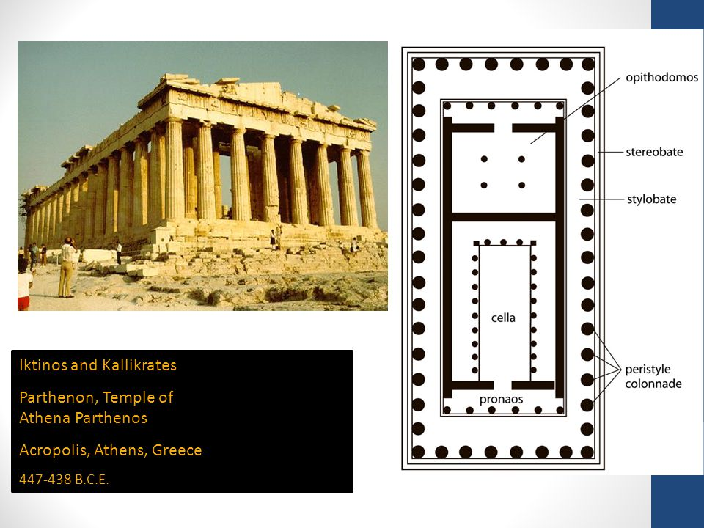

**5) KNOW THE DORIC & IONIC ELEMENTS OF THE PARTHENON**

**6) IDENTIFY THE NARRATIVE & NAMES & LOCATIONS OF THE CHARACTERS OF THE EAST PEDIMENT OF THE PARTHENON**

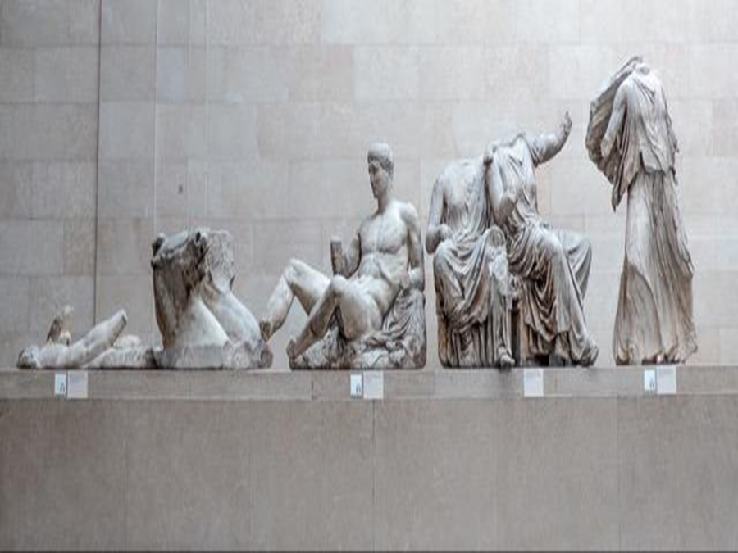

**7) KNOW THE Narrative of the Alexander Mosaic**

**8) KNOW THE NARRATIVE, CONSTRUCTION STYLE & SYMBOLISM OF THE ALTAR TO ZEUS AT PERGAMON**

**9)KNOW THE SIMILARITIES BETWEEN GREEK VASE PAINTING & THE TOMB OF THE TRICILIUM**

**10)KNOW THE DIFFERENCES BETWEEN THE GREEK TEMPLE & ETRUSCAN TEMPLE**

**Identify by Image, Function & Culture**

***(If Greek, ID whether Archaic, Classical or Hellenistic)***

