Name _________________________________________

**Islamic Art: Google Maps Webquest**

Answer the questions below following the instructions.

Go to **google maps and search for *Hagia Sophia***.

Grab your “person icon” from the bottom right and drop it onto the red pin. Explore the 1st and 2nd floor of the building.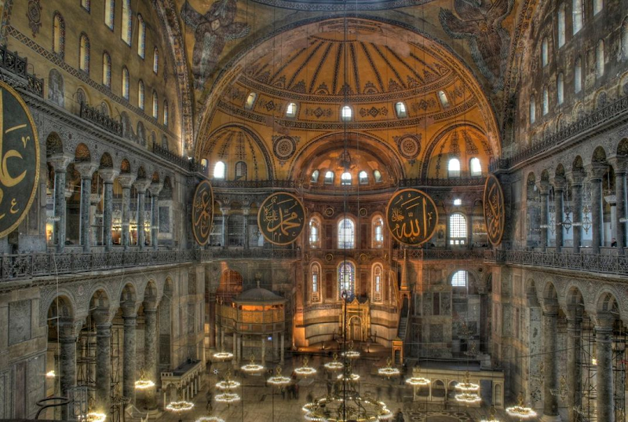

**1)** **Find an example of a mosaic or a fresco.** Describe the subject matter and, using the elements of art and/or principles of design, analyze the image.

**2)** Locate the **clerestory windows** beneath the dome. What was their function *and* religious significance?

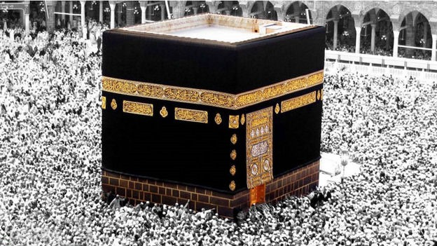

**Go back to google maps and search for *The Kaaba* in Mecca*.***Drop the person icon on top of the red pin.

**3)** What surrounds The Kaaba?

**4)** What other kind of architecture are in the background behind The Kaaba?

**Go to youtube and search for “7 Wonders of the Muslim World and the Kaaba”**. Play the video (2:01 minutes.)

**5)** Why do Muslims pray toward Mecca/The Kaaba?

**6)**What are some beliefs Muslims have about The Kaaba?

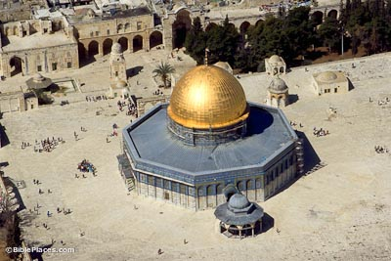

**Go back to google maps and search for *Dome of the Rock* in Jerusalem**. Before you drop the person icon, take a look around the map at the other buildings that surround Dome of the Rock.

**7)** What kinds of buildings are they, function wise?

Click on the**360 image** of the interior on the left of the map to see inside.

**8)** What color is the cornice around the interior?____________

Does it match the column capitals? ______________

What other part of the building is this color? ______________________

**9)**All of the people sitting inside are facing a small niche in the wall - this is called a *mihrab*.

What is the function of the mihrab? ___________________________________

______________________________________________________________________

**10)** What is in the center of the floor? __________________

**Go to youtube and search for “The Dome of the Rock”**. Play the 3rd video (5:18 minutes.)

**11)** Who stood upon the answer to number 10? ________________________________

**12)**What happened when he stood upon it? __________________________________

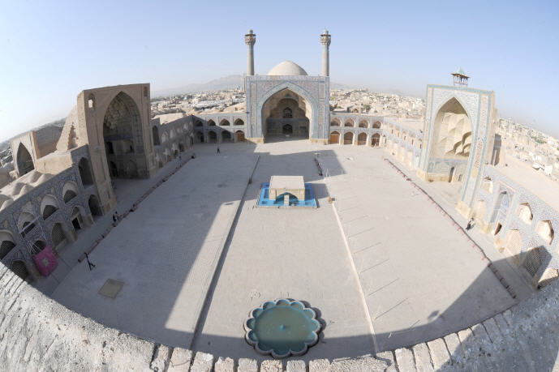

**Go back to google maps, type in *Great Mosque* in Isfahan, Iran.**

**13)** The Great mosque features 4 iwans. Describe the iwan you think indicates the qibla, and why.

**14)**Which part(s) of the building feature a muqarna? __________________________

**Go to youtube and search for “Great Mosque Isfahan”**. Play the 4th video (1:39).

**15)** What kinds of halls are inside, and what are they for?

**16)**Isfahan was the capital for which people?_______________________________

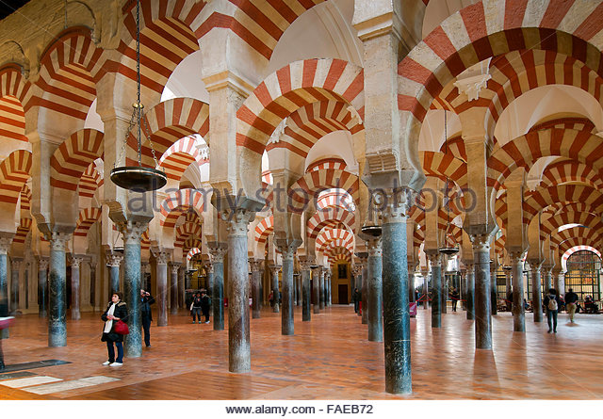

**Go back to google maps, type in *Great Mosque* of Cordoba, Spain.**

**17)** What is a voussoir? _________________________________

_________________________________

**18)** What colors are the voussoirs in this mosque? ______________&______________

**19)** Name another mosque which features voussoirs:____________________________

**20)**Go up and down the main aisle, then take one of the side aisles. What kinds of imagery do you see in the paintings and sculptures?

**Go to youtube & search for “Mosque-Cathedral of Cordoba”**. Play the 1st video. (3:27 minutes)

**21)**What was the building originally? ________________________________

**22)** The building is most notable for: _________________________________________

______________________________________________________________________

**23)** The hypostyle hall features _____________________________, which were a new architectural advancement which allowed for higher ceilings.

**Search for “Granada, Spain: The Exquisite Alhambra” in youtube.** Play the first video (3:56 minutes)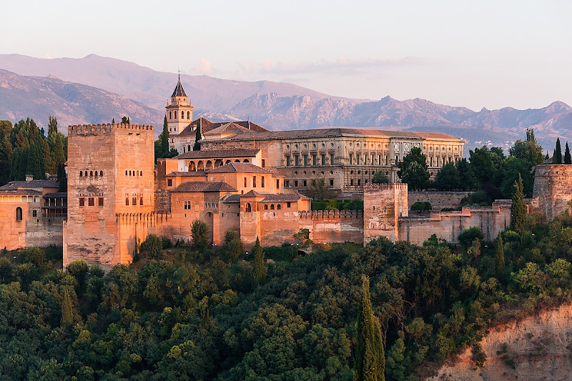

**24)**Alhambra is not a mosque, rather a

________________________________.

**25)** Granada was the capital for which people?__________________________

**26)**These people were excellent at which branch of mathematics? ________________

**27)** This is evident due to which decorative part(s) of the building? _________________

______________________________________________________________________

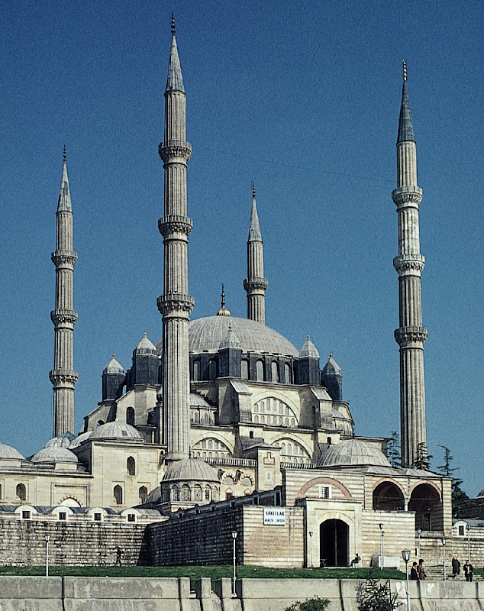

**Search for “Showcase: Ottoman Architect Mimar Sinan”.** Play the 1st video. (3:23 minutes).

**28)** Who was Mimar Sinan an architect for? ________

___________________________________________

**29)**What is the minbar used for? ________________

___________________________________________

**30)**Which Turkish mosque turned Museum is this

inspired by? ________________________________

Compare and contrast two of these buildings:

________________________________________________________________________________________________________________________________________________________________________________________________________________________________________________________________________________________________________________________________________________________________________________________________________________________________________________________________________________________________________________________________________________________________________________