Name Date Period

**Sister Wendy’s A Hero Steps Forward- Giotto Video Analysis**

1. Lamentation Means-

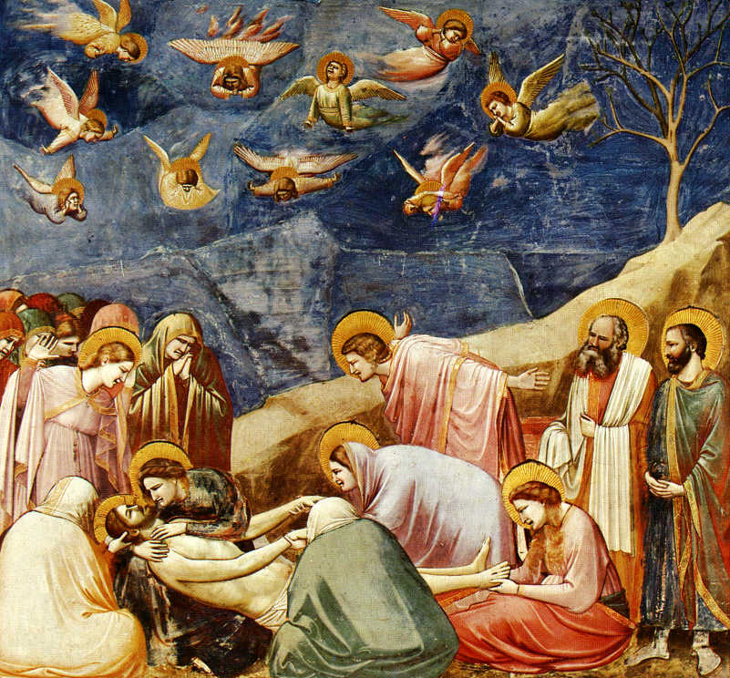

D.

C.

B.

A.

2) Identify and Analyze the following from Sister Wendy’s Video Lecture:

a)

b)

c)

d)

**Proto – Renaissance Art Video 0:00-6:52**

1) FIVE Key Ideas associated with the Ren:

2)Humanism is-

3)The Exit Wall Mural depicts the –

4)The Patron of the Arena Chapel is –

He constructed the Chapel to-

5)The Chapel was built to atone for the sin of _________ which is-

6)Describe the depiction of the devil:

7)The Chapel is constructed with the medium of _____________& tells the narratives of -

8)The Chapel contrasts-

9)One of the functions of the Chapel is-

10) Giotto’s interest in the natural world is reflected in ___________________________________&

____________________________________________________________________________.

11)The compositional devices in Giotto’s Lamentation are-

12)His depiction of the human form is new in his attention to -

13)He seems inspired by-

14)The lines on the Fresco showcase –

**Textbook page 409**

1) He creates bodies that are _____________, ________________________, & _______________________.

2) There are ______framed scenes which tell the stories of -

3)Grisaille is-

4)The chapel ceiling is _____________________________&______________________.

5) The angels are ____________which means __________________________________________.

6)The single dead tree symbolizing-

7) Giotto uses the new devices of ________________________&___________________________>

8)He uses shading –

9) The light in *The Lamentation* falls-

10)Chiaroscuro is-

11) Stage-like setting creates-

12)Giotto’s art synthesized ___________________, _______________& _________________________.

13) He influenced-