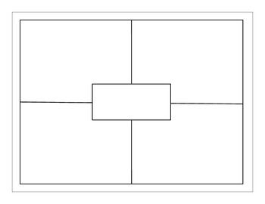

IMAGE OF THE

FLOOD SCENE

Function:

Art Themes

**CONTEXT:**

Patron:

Audience:

Greco-Roman Features:

Renaissance Features:

**CONTENT:**

Narrative:

Figures:

Art Technique:

Symbolism:

Problems with Depiction:

Contrast:

C-  
L-  
A-  
S-  
S-

MATERIALS/MEDIUM-