**Complete the following for the Japanese Work**

**White and Red Plum Blossoms, Ogata Korin**

1)Construct the F2C2 using the Model Below

Please write the Question & Answer

2)Draw the image Using the Exact Colors

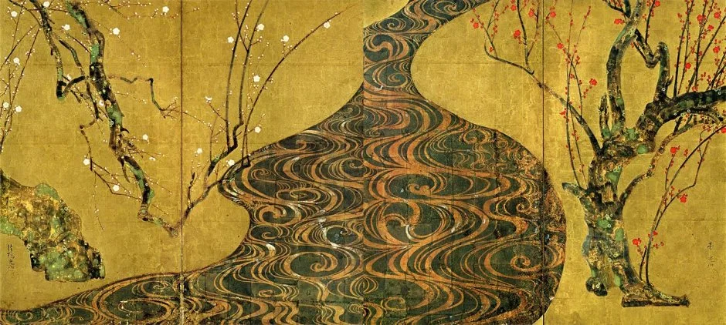

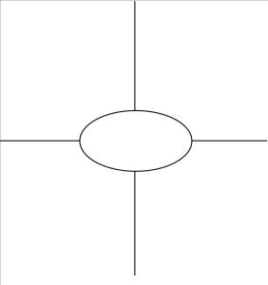

**Using the following websites-*Answer the following Questions***

<http://www.moaart.or.jp/en/?collections=053>

1)Where is the white plum trunk?

2)Where is the red one?

3) What impression does the stream give?

4) What does the stream symbolize?

5) What is “Korin’s Plum Flower”?

6)What technique does he employ?

<http://research.honolulumuseum.org/EdoPainting/introduction-styles-of-japanese-painting-during-the-edo-period-1615-1868/rinpa-painting/631-2>

7)Korin is familiar with ______&______and studied under___________.

8)He was known for painting_______________.

9) His favorite subject is___________________.

10) His composition emphasizes ________but also_________________,

11) Balance is achieved through________________________________.

12) What dis he use to create the red plum blossom?

13)This technique is associated with_________________________

**Using the following websites-*Answer the following Questions***

<https://www.khanacademy.org/humanities/ap-art-history/south-east-se-asia/japan-art/a/ogata-krin-red-and-white-plum-blossoms>

1) Korin transforms the Landscape into-

2) Where is the work abstract & realistic?

3) What does Gold so in the work?

4) What causes the upward tilt?

5) How are the tree trunks constructed?

6) What does the audience experience viewing the work?

7) Which season is depicted?

8)When did he create this work?

9) What “ism” & artist did this work influence?

10) *RINPA* means-

11) *Tarashikoma* means-

12) *Mokkotsu* means-

<https://ohsapah.wordpress.com/2018/02/13/210-white-and-red-plum-blossoms/>

13)How does it create a 3- dimensional illusion?

14)The trees are formed by _____& the river by__________

15) Rinpa is a combination of___, ___, _____, ____&_____.

**White and Red Plum Blossoms, Ogata Korin**

**Material:**

**Culture of Origin:**

**Year of Origin:**

Function of Work:

Art Themes:

Change from Traditional Yamato-e Painting:

C-

L-

A-

S-

S-