Name Date Period

**Art Research & Comparison Activity**

1. **Using Your Notes & Research Complete the Following Questions**
2. **Write (2) AP Short Responses=**
3. **How are these works visually and contextually similar? B) How are they Different?**

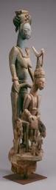 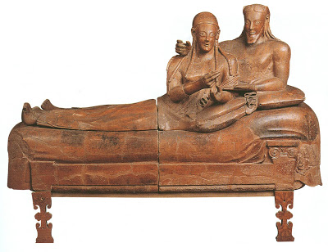

***Veranda Post of Enthroned King Sarcophagus of the Spouses***

**Culture: Culture:**

**Size & Shape: Size & Shape**

**Material/Medium: Material/Medium:**

**Figures & Forms: Figures & Forms:**

**Color & Line: Color & Line:**

**Proportions: Proportions:**

**Narratives: Narratives:**

**History: History:**

**Original Location: Original Location:**

**Usage/Purpose: Usage/Purpose:**

**Meaning & Themes: Meaning & Themes:**