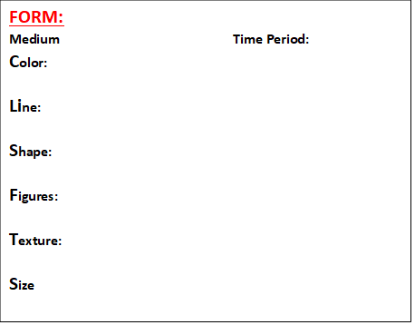

**CONTEXT**

**CONSTRUCTED for (Patron):**

**(3) Facts about the Sculptor:**

**Historical Period:**

**Primitive because-**

**Radical because-**

**Draw the Sculpture:**

**CONTENT:**

**Depicts-**

**Modernism=**

**Reductive-**

**Experimental-**

**Distorted-**

**Rejects Realism-**

**Attempts to maintain-**

**FUNCTION**

**ART THEME:**

**ICONIC BECAUSE-**

**INFLUENCED BY –**

**TITLE-**

**ARTIST-**

**Year of origin:**