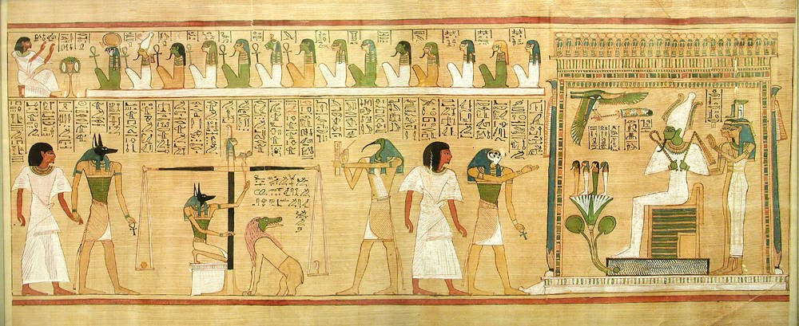

I

H

G

F

E

D

C

B

A

1. **IDENTIFY:**

<https://smarthistory.org/hunefers-judgement-in-the-presence-of-osiris/>

A) E) I)

B) F)

C) G)

D) H)

1. W**atch the Video & Answer the Following Questions:**

[**https://www.youtube.com/watch?v=WceVwMdN0eE**](https://www.youtube.com/watch?v=WceVwMdN0eE)

a) What is the Last Judgement of Hunefer made of?

b) Describe this medium origin & importance in Egyptian Society

c)The Book of the Dead contains___________, _________&___________.

d) What is a Pyramid text?

e) Who is Hunefer? What is his status?

f) On the scroll, what is happening at the top?

g) On the scroll, what is happening at the bottom?

h) Anubis is associated with _______,_______&__________, and carrying an _______-a symbol of__________.

i) What is in the jar on the left side o the scale? Why?

j) Who is Ma’at?

k) Who is Thoth? Who is Osiris?

l) What is the meaning of the Lotus blossom? Who stands on it? Why?

m) What is the white foundation of the building on the scroll? How is it important in Egyptian Funerary tradition?

n) How is *Preservation* a key idea in Egyptian art?

1. **Construct a V/ C Analysis:**

**VISUAL CONTEXTUAL**

**C= 1)**

**L= 2)**

**A= 3)**

**S= 4)**

**S= 5)**