Name Date Period

***Art of the English Enlightenment***

**The Tête à Tête, from Marriage a la Mode, William Hogarth**

**Video-** <https://www.khanacademy.org/humanities/ap-art-history/early-europe-and-colonial-americas/reformation-counter-reformation/v/william-hogarth-s-marriage-a-la-mode-c-1743>

**0:00- 2:25**

**1) Hogarth is best known for________________________________________________________.**

**2) The Industrial revolution has created a _____________________________________________.**

**3) A new _____________________class emerges that is powerful because___________________.**

**4) How is Hogarth a financial success?**

**5) He often makes fun of the _______________________________________________________.**

**6) The *Marriage a la Mode* print series focus es on criticizing_______________________________.**

**7) *Marriage a la Mode* means-**

**8) What type of economic deal is taking place? Why?**

**4:04-6:40**

**9) Tete a tete means-**

**10) The husband is recovering from-**

**11) The dog is-**

**12) The wife clothes are ________________________ & she looks________________________.**

**13) The chair suggests-**

**14) Music is symbolic of-**

**15) Why is the accountant /butler upset?**

**16) What does the contrast on the mantle suggest?**

**17) Why is the painting with the naked foot curtained?**

**18) What moral or idea is the mantle communicating? What element suggests that?**

***Textbook: page 740-741***

**1) Where did the English acquire their paintings?**

**2) Hogarth’s work is similar to ___________________________________________.**

**3) Hogarth translated _______________________________into the visual arts.**

**4) His favorite device was-**

**5) The Breakfast scene from Marriage a la Mode focuses on –**

**6) The Marriage al la Mode was published as ________________________________,**

**70 Identify these elements: A) Wife B) Husband C) Dog D)Lacy Cap Protruding from The Husband’s pocket E) Unpaid Bills F) The Curtained Erotic Painting G) (2) Greco- Roman Architectural Details**

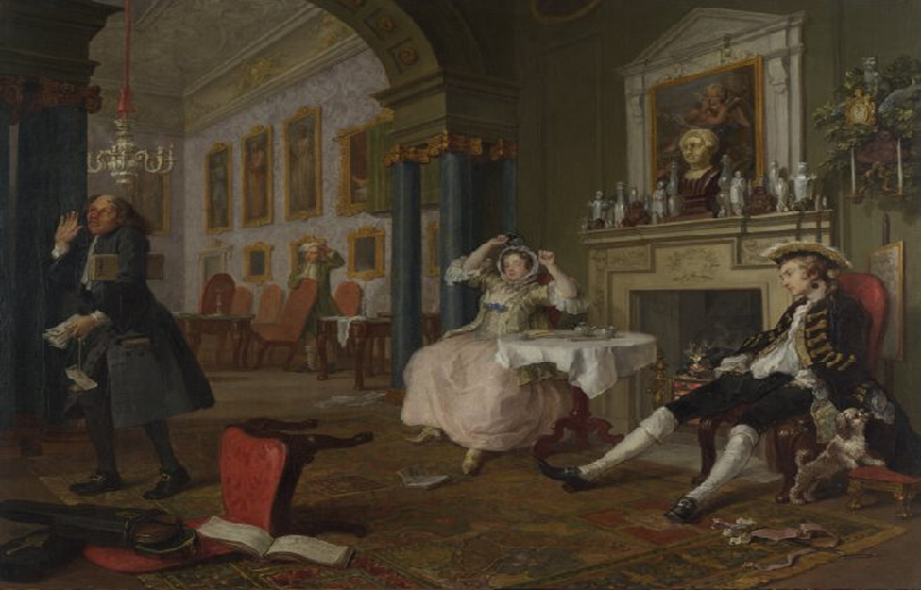

**A Philosopher Giving a Lecture on the Orrery, Joseph Wright of Derby**

***Khan Academy Essay #100***

***1) Medium of the work?***

***2) Size of the work?***

***3) Key Idea of the Age of Enlightenment?***

***4) Philosophic shift?***

***5) Age of Enlightenment associated with?***

***6) Derby painted scientist & philosophers like____________________ &______________________.***

***7) Derby was known for___________________________ & _______________________________.***

***8) The paintings moral?***

***9) The painting mimics?***

***10) How is it like Caravaggio’s Calling of St Matthew?***

***11) Function of an Orrery?***

***12) Who might the philosopher be?***

***13) How does it have a high dramatic impact?***

***Textbook: pages 726-27***

**1) What is the new way of thinking that appeared in the 18th century?**

**2) This new way of thinking rejected _________________________________________________& promoted________________________________________________________________________.**

**3)It encouraged_________________________________________________________________.The scientific advancement included___________________________&__________________________.**

**4) The main ide of Derby’s painting was________________________________________________.**

**5) What are the children doing in the painting?**

**6) Why?**

**7) What is an orrery?**

**8) How is it showcased in the painting?**

**9) What is the term for the shadowy & dark background?**

**10) Identify these elements on the painting: A) lecturer, B) the woman, C) the orrery D) the note -taker E) the books**

