Name Date Period

**Art of Korea**

<https://sitebuilder.yola.com/#site/0da845d2e12d48e39db1a0e9685ac262/page/8d862afecab5455697ccaa9144deb6c9>

1)The Gold and Jade Crown is from the ___________kingdom & made from_______________________.

2) The crown was found in _________________& the gold is _______& ________so it wouldn’t with stand_____________________________________________& anticipates a ______________________.

List (2) other works of the 250 that illustrates the afterlife:

3) The function is___________________________& __________________________________________

4) Korean Shamanism is similar to Shintoism=

5)The structure of the crown resembles_____________, __________________&___________________.

6) The crown may serve to make the kings __________________________________________________.

7) The vertical elements of the crown represent=

8) The crown is similar to the Indian ________ in that it represents the __________________________.

9) The antlers represent=

10) The dangling gold and jade symbolize=

11) Chinese Tang dynasty represented =

12) ________________came to Korea because of strong ties to the tang dynasty.

13)________________continued as the sate religion.

14) The Portrait of Sin Sukju shows influence of_______________________& wee literati which means=

15) List (3) Chinese influenced characteristics of the portrait:

16) These portraits are sponsored by the _________________& include a _______________________.

17) The facial features are meant to convey=

18) Korean’s believed the face could reveal___________________ and can be seen in the art details of

_______________________&__________________________on the portrait.

19) Song’s Summer Trees showcases a strong connection between ____________________in its______.

**Create a F2C2 on Song’s Summer Trees**

<https://www.khanacademy.org/humanities/ap-art-history/global-contemporary/a/song-su-nam-summer-trees>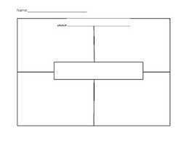

**C**

**L**

**A**

**S**

**S**

