ACROPOLIS ART ANALYSIS

1) Fold Paper into (3) Horizontal Sections
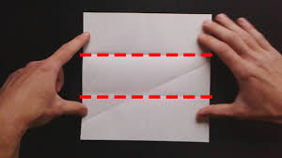
2) Create (4) Vertical Division
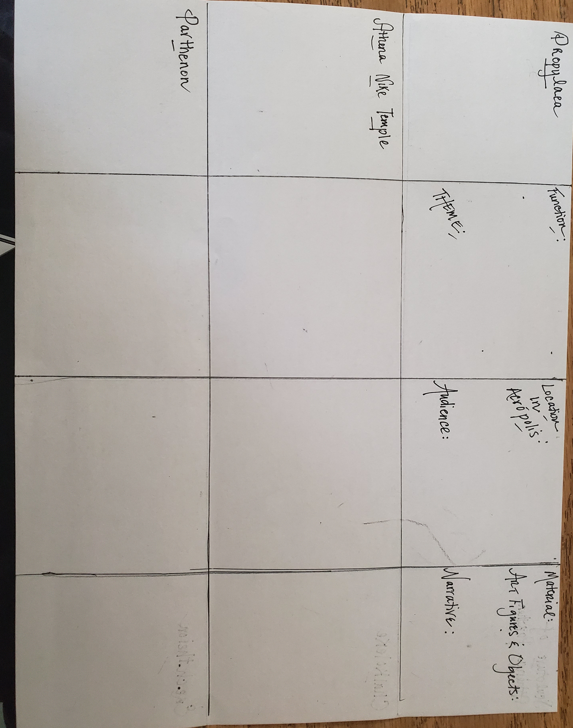
3) The Front Three Buildings: Propylaea, Athena Nike Temple & Parthenon
The Back Three Buildings:
Sculpture of Athena Parthenos, Chalcothece & Erechtheion

4) For Each Building: Column 1) Id. The Attribution & Draw it
(Attribution: Title, Year of origin, Material & Culture)
2) Id. the Function & Art Theme
3) Id. The Location in the Acropolis & the Audience
4) Id. the Material, Art Figures/Objects & Narrative

