**REALISM LECTURE ANALYSIS**

**1) List (4) Characteristics of Gothic Revival in the Ho*use of Parliament*-**

**2) List the (7) ideas about the *Rise of Modernism***

**3) List the (6) Art Movements that build *Early Modernism.***

**4) List (5) background ideas about *Realism.***

**For Each of the following Works list (5) characteristics or ideas associated with Art**

***5) The Stone Beakers by______________________________.***

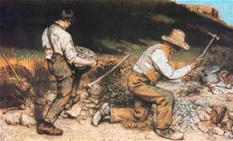

***6) Burial at Ornan by __________________________________.***

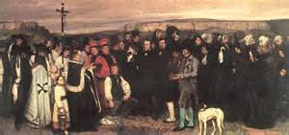

***7) The Gleaners by ___________________________________.***

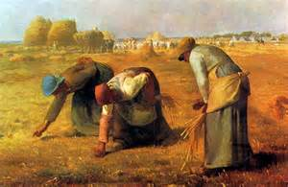

***8) Third Class Carriage by _________________________________.***

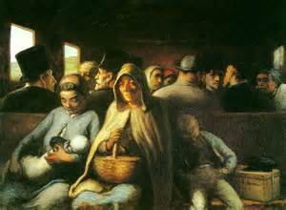

***9) Nadar Raising Photography by _______________________________.***

