Name Date Period
Art Photography Timeline
Identify the Image | Photographic Process &  Formal Characteristics | Context
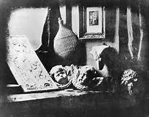
Still Life in Studio
Photographer-
Date-
Culture-
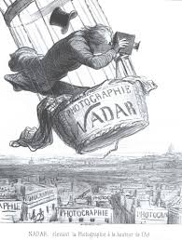
Nadar Raising Photography to the Height of Art
Photographer-
Date-
Culture-
Medium-
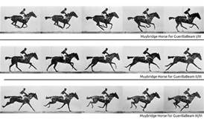
The Horse in Motion
Photographer-
Date-
Culture-
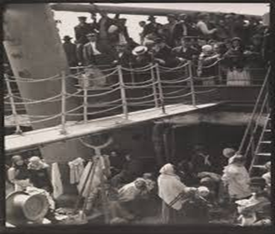
The Steerage
Photographer-
Date-
Culture-
Medium-
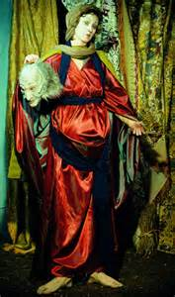
Untitled #228 By Cindy Sherman

Date-
Culture-
Medium-

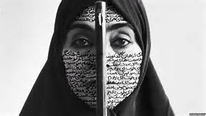
Rebellious Silence

Artist-
Date-
Culture-
Medium-

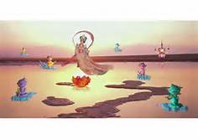
Pure Land

Artist-
Date-
Culture-
Medium-

