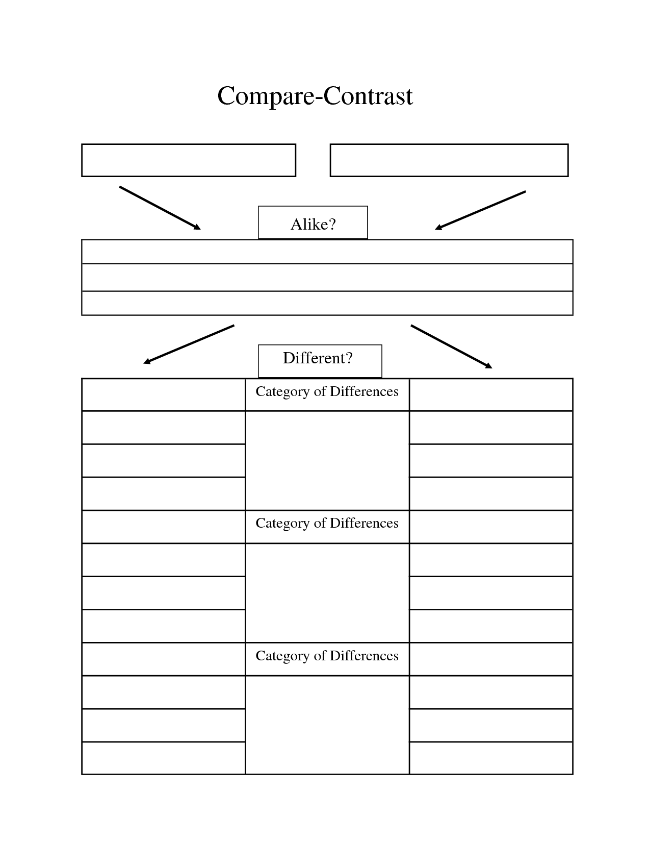

HOW ARE THESE WORKS POLITICAL STATEMENTS?

CONTEXT

FORM

& CONTENT

FUNCTION & AUDIENCE

RESPONSE