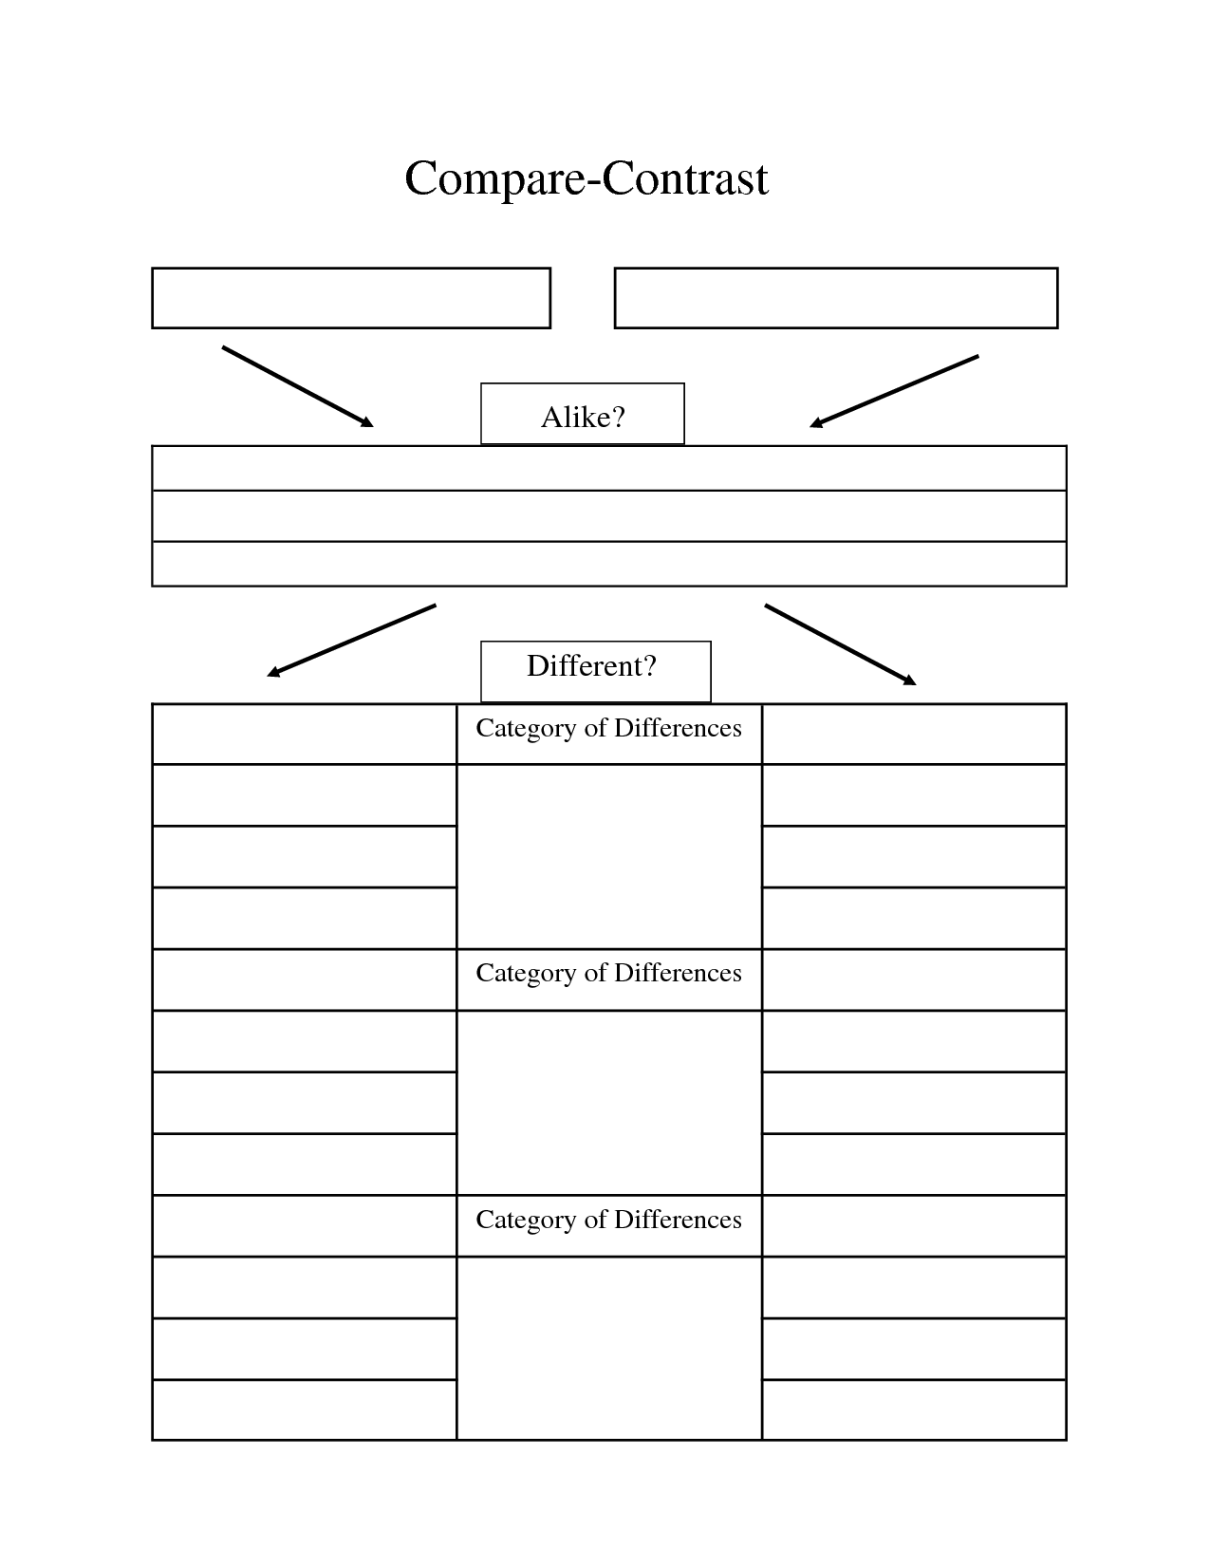

**Alberti’s *Palazzo Rucellai***

**Brunelleschi’s *Pazzi Chapel***

How do these architectural works communicate cultural meaning?

1) 2) 3)

2)

3)

CONTEXT

LOCATION,

FORM

& CONTENT

FUNCTION & AUDIENCE

RESPONSE