Name Date Period

**The Great Stupa at Sanchi**

Identify the following Features:

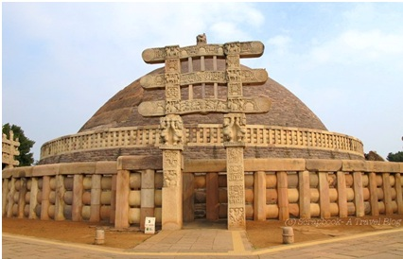

|  |  |
| --- | --- |
| Define STUPA: | How this Structure a *Sacred Space*?  Provide Evidence of the Following Elements |
| Culture: | 1) Elevated= |
| Religious Belief: | 2) Transitions from the Everyday to the Sacred= |
| Location: | 3) Visually Beautiful= |
| Year of Completion: | 4) Monumental in Size= |
| Materials: | 5) Narrative Art= |
| Function: | 6)Narrative Art= |
| Patron: | 7)Light Filled= |