VOCABULARY:

1. Altarpiece 13. Trompe l’oeil
2. Annunciation 14. Cassoni
3. Engraving 15.Chiaroscuro
4. Etching 16. Sfumato
5. Triptych 17. Loggia
6. Woodcut 18. Entombment
7. Chapter House 19. Sibyl
8. Humanism 20. Ignudi
9. In Situ 21. Mannerism
10. Linear Perspective 22. Tondo
11. Orthogonal 23. Pietra Serena
12. Pilaster

KNOW THESE CONCEPTS:

\*(6) Characteristic of Northern European Art ( like a walnut)

\*(3) Panels of the *Merode Altarpiece*

\*(3) Symbols in *The Arnolfini Portrait*

\*The images and meaning of the center of *The Arnolfini Portrait*

\*(3) Images on the Front Panels of the *Isenheim Altarpiece*

\*(3) Images on the Second Layer Panels of the *Isenheim Altarpiece*

\*Meaning of the *Allegory Law and Grace* (Protestant & Catholic sides with theology)

\*Horizontal Diagonal in *Return of the Hunter*- composition and purpose

\*Classical Elements of the Pazzi Chapel

\*Similarities between Palazzo Rucellai Palace & the Coliseum

\* (3) Compositional Elements of *Birth of Venus-* roses, zephyrs & inspiration for Venus

\* Meaning of (3) Compositional Elements of Donatello’s *David-* medium*,* hat and foot

\* (10) Characteristics of Renaissance Painting

\* (4) Image Layers of Michelangelo’s *Last Judgment*

\*Architecture, Roman gods , (2) center Philosophers & tribute to Michelangelo in *The School of Athens*

\* Differences Between Italian & Venetian Renaissance

\*(3) Elements of the Façade of Giacomo della Porta & subject of the ceiling

\* (4) Characteristics of Mannerism

ID the Image by Title and Artist:

1. 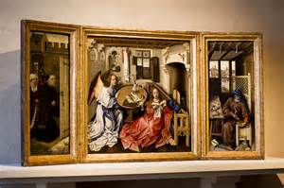 2. 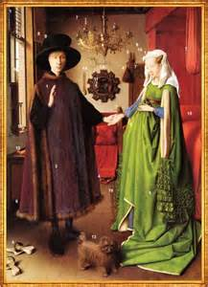 3. 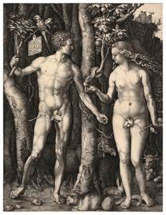

4. 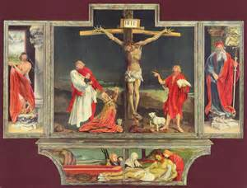 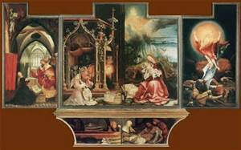5. 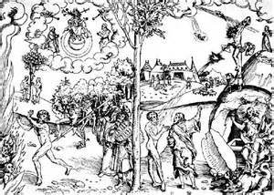

6. 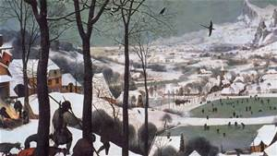 7. 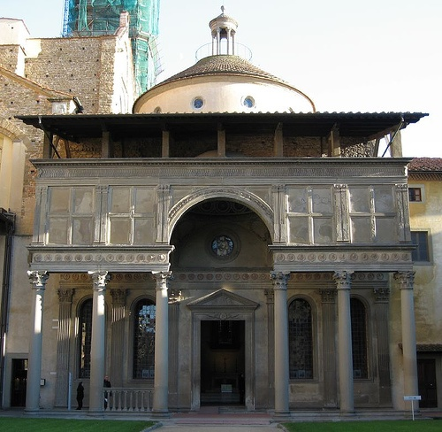8. 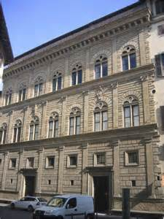

9. 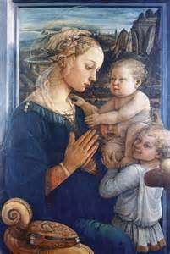10. 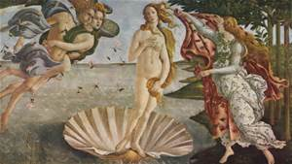 11. 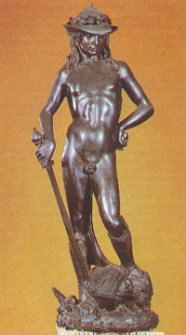

12. 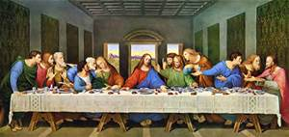 13. 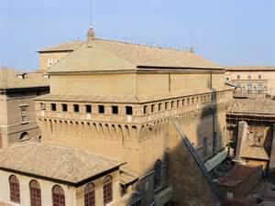14. 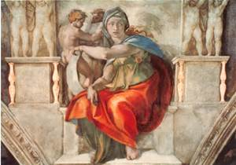

15. 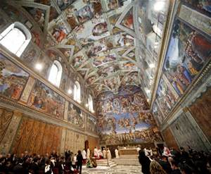 16. 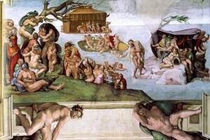17. 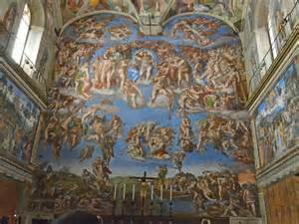

18. 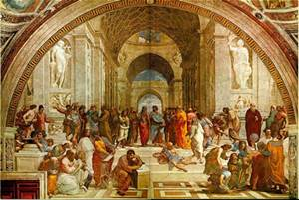 19. 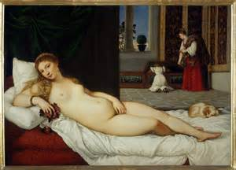

20. 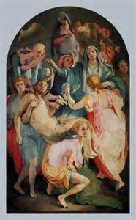

21. Identify the Elements, Title , Artist & Style

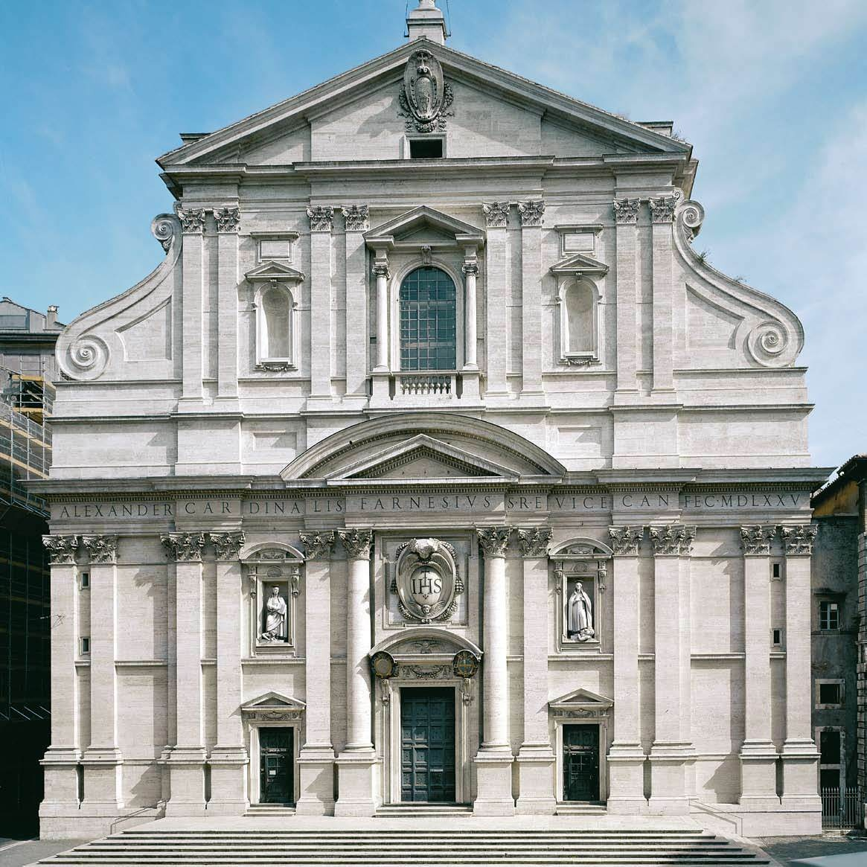

F)

D)

E

C)

B)

A)