Construct an Analytical Poster

(No Bigger than 11X18)

That Deconstructs a Northern European Renaissance Work using F2C2

*Use the Resources on Khan Academy, the Textbook & the Internet*

[arthistory/a/required-works-of-art-for-ap-art-history](https://www.khanacademy.org/test-prep/ap-art-history/introduction-ap-arthistory/a/required-works-of-art-for-ap-art-history)

Image of the Work with (5) Elements Identified

https://www.khanacademy.org/test-prep/ap-art-history/introduction-ap-

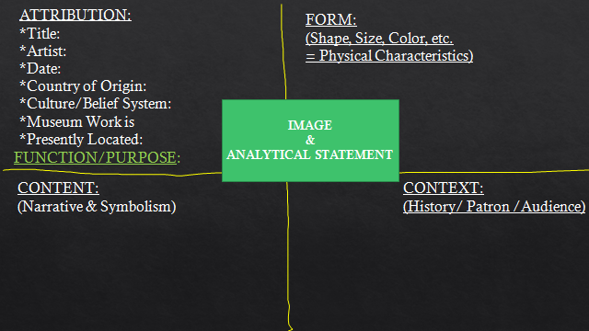

4 Characteristics that Reflect the Walnut Analysis Strategy

ANALTICAL STATEMENT

WITH IMAGE OF SYMBOLIC ELEMENT (S)

Analytical Statement:

____ *artist name*_____is a _*3 adjectives*______artist from________

Whose works_____*title*________ focuses on the subject of ___________

and is constructed using the *medium & technique*. Symbolic aspects of this work are the_______________ which means_________.