Museum Curator Assignment

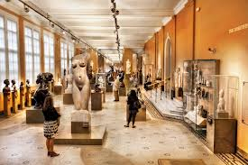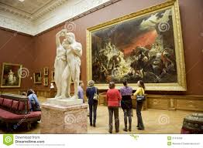

Museum curators arrange art in various ways-time period, style, color, subject, influences and theme to name a few.

Using the *Thematic Graphic Organizer*, compare and contrast a painting from the Impressionism movement with one from the Neoclassical, Romantic or Realist movement.

Be sure to choose painting that share some commonality-

color, theme, subject, intent, shape, scale, influence etc.