Name

Date

Period

**Baroque – Neoclassical Art**

***Identify A) Title & Artist***

***B) Medium***

***C) Function/Purpose***

***D) Art Style***

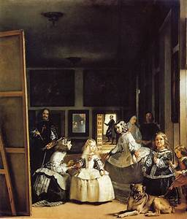

***1)***

***A)***

***B)***

***C)***

***D)***

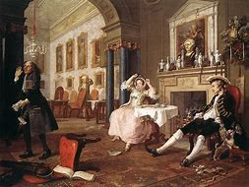

***2)***

***A)***

***B)***

***C)***

***D)***

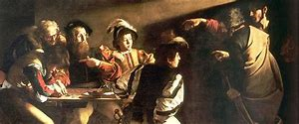

***3)***

***A)***

***B)***

***C)***

***D)***

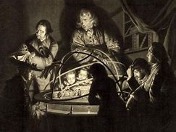

***4)***

***A)***

***B)***

***C)***

***D)***

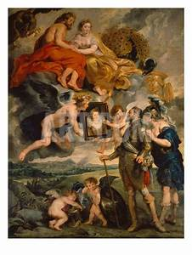

***5)***

***A)***

***B)***

***C)***

***D)***

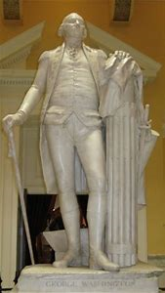

***6)***

***A)***

***B)***

***C)***

***D)***

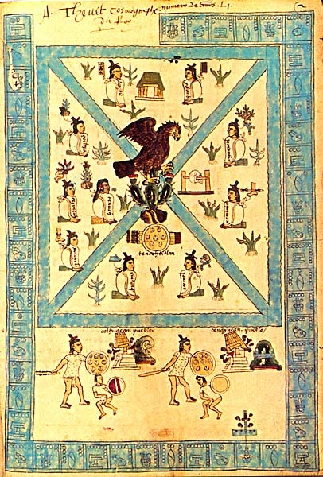

***7)***

***A)***

***B)***

***C)***

***D)***

[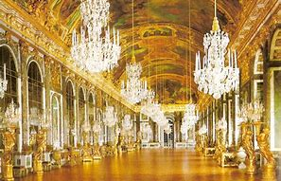](https://www.bing.com/images/search?view=detailV2&ccid=sUf%2bUyOg&id=E387145FC64AA090708600E464E6746A85B9B889&thid=OIP.sUf-UyOgUAgus3O77S22FwHaE8&mediaurl=https://lucyfitzgerald.files.wordpress.com/2014/03/hall-of-mirrors.jpg&exph=600&expw=900&q=hall+of+mirror&simid=608003557715543881&selectedIndex=56&cbir=sbi)

***8)***

***A)***

***B)***

***C)***

***D)***

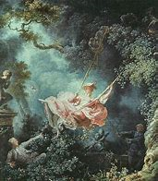

***9)***

***A)***

***B)***

***C)***

***D)***

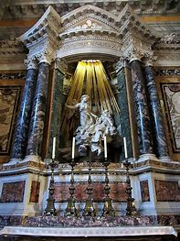

***10)***

***A)***

***B)***

***C)***

***D)***

[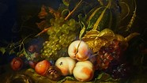](https://www.bing.com/images/search?q=ruysch+fruit+and+insects&id=529910DD544FB2414E5B4D9B10706EB0C7E8A5E4&FORM=IQFRBA)

***11)***

***A)***

***B)***

***C)***

***D)***

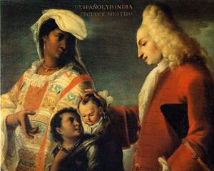

***12)***

***A)***

***B)***

***C)***

***D)***



***13)***

***A)***

***B)***

***C)***

***D)***

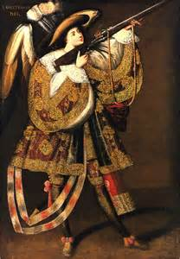

***14)***

***A)***

***B)***

***C)***

***D)***

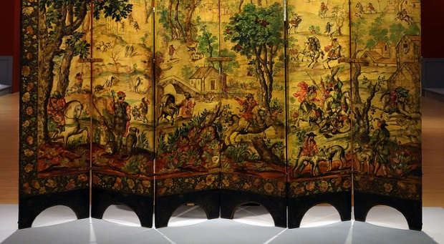

***15)***

***A)***

***B)***

***C)***

***D)***

[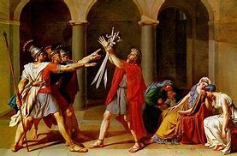](https://www.bing.com/images/search?view=detailV2&ccid=jWIKll0E&id=F02045CC91308909E7AD36424AE7933079F9518A&thid=OIP.jWIKll0ED2sE52CdByQEWgAAAA&mediaurl=https://www.theartist.me/wp-content/uploads/2015/07/Oath-of-the-Horatii.jpg&exph=262&expw=400&q=oath+of+horatii&simid=608038115021032400&selectedIndex=1)

***16)***

***A)***

***B)***

***C)***

***D)***

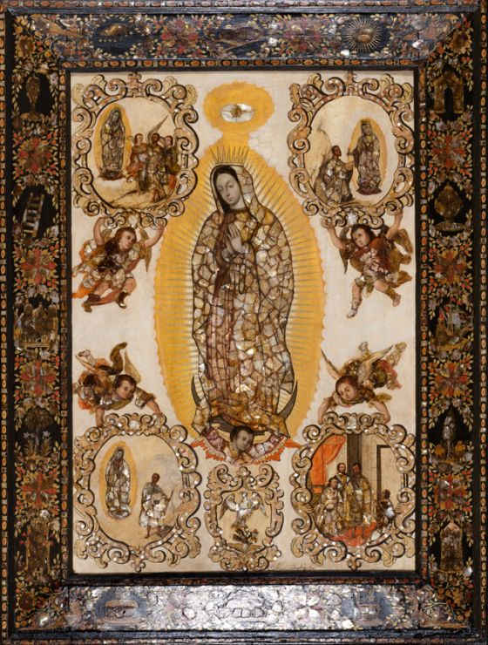

***17)***

***A)***

***B)***

***C)***

***D)***

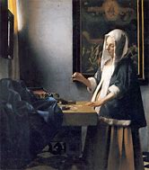

***18)***

***A)***

***B)***

***C)***

***D)***



***19)***

***A)***

***B)***

***C)***

***D)***

[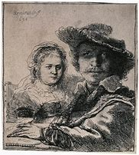](https://www.bing.com/images/search?view=detailV2&ccid=vQo9flnM&id=1E2A6506BAA51A02BB479B1717FFC2885A557D21&thid=OIP.vQo9flnMRkYUUqpxgPKuhQHaIN&mediaurl=https://upload.wikimedia.org/wikipedia/commons/4/4e/Rembrandt_-_Self-Portrait_with_Saskia_-_WGA19077.jpg&exph=797&expw=719&q=rembrandt+slf+portrait+with+saskia&simid=608051017103836316&selectedIndex=1)

***20)***

***A)***

***B)***

***C)***

***D)***

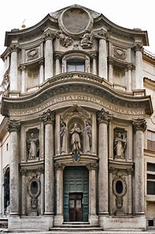

***21)***

***A)***

***B)***

***C)***

***D)***

**

***22)***

***A)***

***B)***

***C)***

***D)***

***23)***

***A)***

***B)***

***C)***

***D)***

[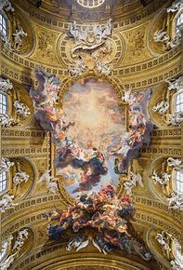](https://www.bing.com/images/search?view=detailV2&ccid=PKW//qso&id=FC5D6D5BC7F068CCA05AB4EFBCD7FDC0823AF0DE&thid=OIP.PKW__qsoh44MSvt9YitCaAHaK2&mediaurl=https://s-media-cache-ak0.pinimg.com/736x/54/fc/a4/54fca485a05a3aef0e95aa1abfae27f7.jpg&exph=1079&expw=736&q=truimph+of+the+holy+name+of+jesus&simid=608041357714001570&selectedIndex=10)

***24)***

***A)***

***B)***

***C)***

***D)***

