Identification | Form (elements of art and design principles) | Art-making process (materials and techniques)
Content (subject/iconography) | 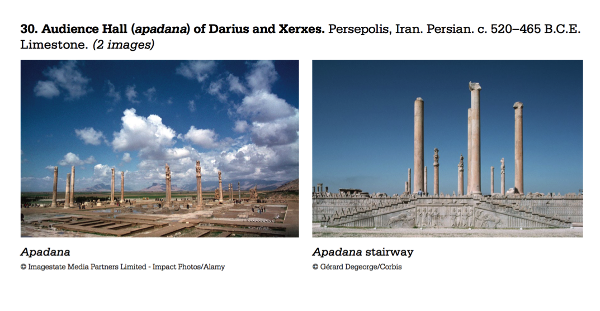 | Original context/audience
Intended function/purpose | Artistic innovation/convention | Themes:  Define:  Apadana-  Hypostyle Hall-  Tribute-  Persian Empire-  facade

