2009 AP Short Response

The slide shows a manuscript page.

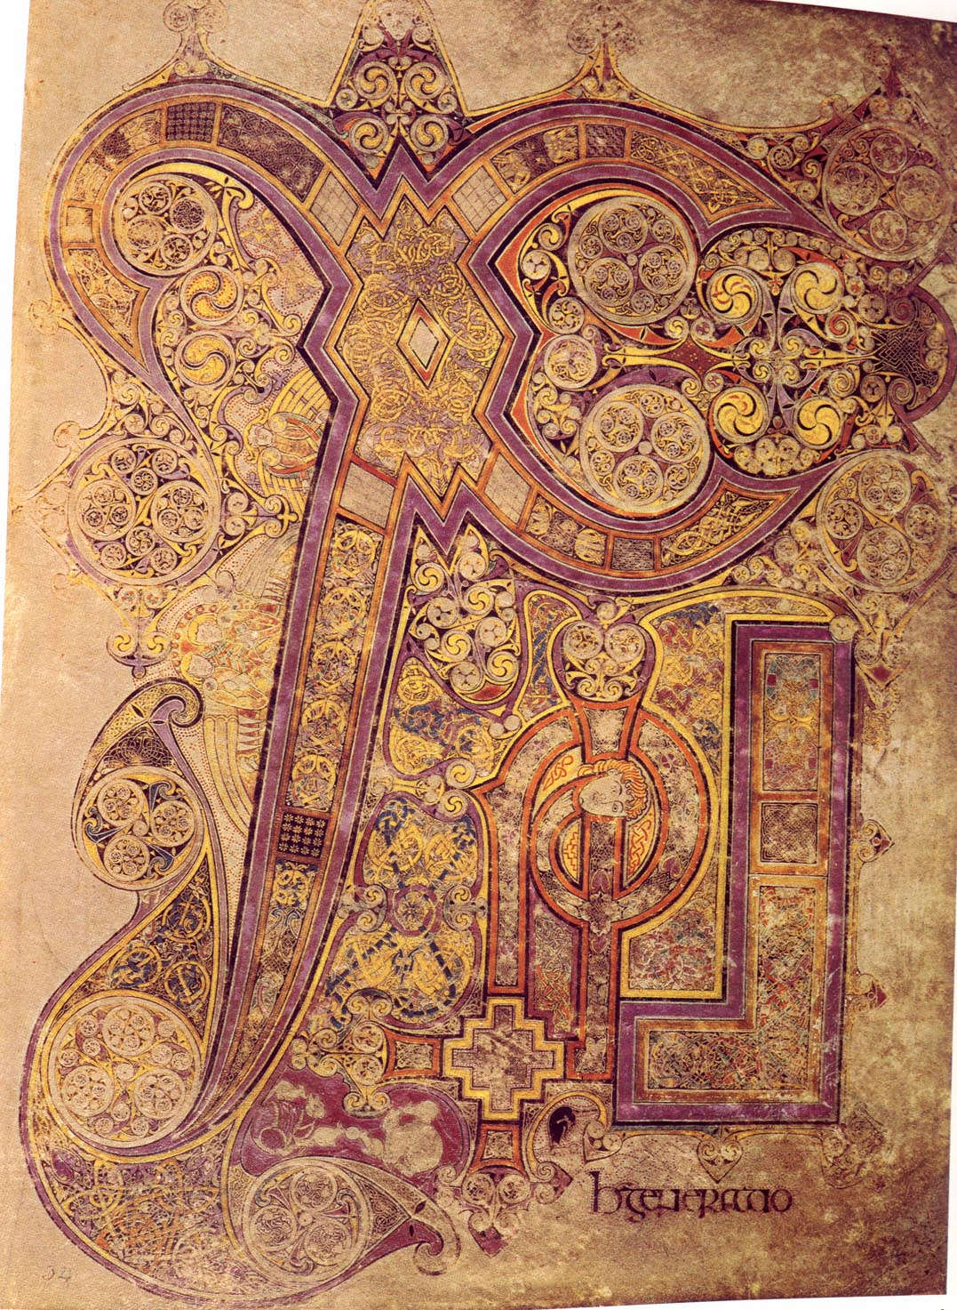

Identify the culture in which the manuscript page was made. How is the manuscript page characteristic of its culture? (5 minutes)